PITCH PERFECT: DATA-DRIVEN PREDICTIONS FOR THE BEST CRICKET SQUAD DATA SCIENCE AND MACHINE LEARNING FRAMEWORK

A PROJECT REPORT

Submitted by

SHAKEEL AHAMED (210071601164)

SYED AFTAB (210071601176)

Under the guidance of
Mrs. M. VETRIPRIYA

In partial fulfilment for the award of the degree of BACHELOR OF TECHNOLOGY

in
COMPUTER SCIENCE AND ENGINEERING



APRIL 2025



BONAFIDE CERTIFICATE

Certified that this project report “Pitch Perfect: Data-Driven Predictions for the Best Cricket Squad: Data Science and Machine Learning Framework” is the bonafide work of “SHAKEEL AHAMED R (210071601164) AND SYED AFTAB S (210071601176)” who carried out the project work under my supervision. Certified further, that to the best of our knowledge the work reported herein does not form part of any other project report or dissertation on the basis of which a degree or award was conferred on an earlier occasion on this or any other candidate.

SIGNATURE

Mrs. M. VETRIPRIYA
SUPERVISOR
Assistant Professor Department of CSE
B.S. Abdur Rahman Crescent Institute of Science &Technology Vandalur, Chennai – 600 048
SIGNATURE

Dr. AISHA BANU W
HEAD OF THE DEPARTMENT
Professor Department of CSE
B.S. Abdur Rahman Crescent Institute of Science &Technology Vandalur, Chennai – 600 048



VIVA VOCE EXAMINATION

The viva voce examination of the project work titled “Pitch Perfect: Data-Driven Predictions for the Best Cricket Squad: Data Science and Machine Learning Framework”, submitted by “SHAKEEL AHAMED R (210071601164) AND SYED AFTAB S (210071601176)” is held on .

INTERNAL EXAMINER EXTERNAL EXAMINER

ACKNOWLEDGEMENT

We sincerely express our heartfelt gratitude to Prof. Dr. T. MURUGESAN, Vice chancellor and Dr. N. THAJUDDIN, Pro-Vice Chancellor, B.S. Abdur Rahman Crescent Institute of Science and Technology, for providing us an environment to carry out our project successfully.
We sincerely thank Dr. N. RAJA HUSSAIN, Registrar, for furnishing every essential facility for doing our project.
We thank Dr. SHARMILA SANKAR, Dean, School of Computer, Information and Mathematical Sciences for her motivation and support.
We thank Dr. AISHA BANU W, Professor and Head, Department of Computer Science and Engineering, for providing strong oversight of vision, strategic direction and valuable suggestions.
We express our sincere thanks to the Project Review Committee members, from the Department of Computer Science and Engineering, Dr. S. REVATHI, Professor and Dr. ARULARASAN. A. N, Associate Professor for their valuable suggestions and support.
We obliged our project supervisor Mrs. M. VETRIPRIYA, Assistant Professor, Department of Computer Science and Engineering for her professional guidance and continued assistance during our project.
We thank class advisor and project coordinator Mr. S.R. SENTHILKUMAR, Assistant Professor, Department of Computer Science and Engineering for his professional guidance and continued assistance throughout the project period.
I thank all the Faculty members and the System Staff of the Department of Computer Science and Engineering for their valuable support and assistance at various stages of project development.

SHAKEEL AHAMED R SYED AFTAB S

ABSTRACT

In the dynamic world of sports analytics, data-driven insights are now central to strategic decision-making. This project is centered on web scraping and analysis of match and player statistics from the ICC Men's T20 World Cup 2022, obtained from ESPNcricinfo. By using Python libraries like requests and BeautifulSoup to automate the process of data extraction, the project creates detailed batting and bowling summaries for all tournament matches. The scraped data is organized into JSON format and put away for subsequent analysis. Special attention is paid to scraping granular information like individual scores, strike rates, wickets, economy rates, and types of dismissal. The project is also modular, starting with gathering match URLs, then parsing scorecard tables for innings as well as players' contributions. As soon as data becomes available, it is represented on platforms such as Power BI in order to disclose trends and cross-player and cross-team performances. This information aids in the detection of leading players, assessing constancy, as well as comprehend match-winning contribution. The processed data also goes into predictive modeling work that tries to recommend an ideal playing XI using past metrics. In addition, the modularity enables future integration with real-time updates and extension to other tournaments. Essentially, the project is a marriage of web automation, data engineering, and sports analytics to build a solid framework for cricket performance analysis. It illustrates how smart systems can promote fan experience and professional analysis in the sports arena.

TABLE OF CONTENTS

CHAPTER NO. | TITLE | PAGE NO.
 | ABSTRACT | IV
 | TABLE OF CONTENTS | V
 | LIST OF ABBREVIATIONS | VIII
 | LIST OF FIGURES | IX
1 | INTRODUCTION | 1
1.1 | OVERVIEW | 1
1.2 | OBJECTIVE | 2
1.3 | SCOPE OF THE STUDY | 2
1.4 | SIGNIFICIANCE | 4
1.5 | PROBLEM STATEMENT | 4
1.6 | TARGET AUDIENCE | 6
1.7 | OUTCOME EXPECTATIONS | 6
2 | LITERATURE SURVEY | 7
3 | SYSTEM ANALYSIS | 10
3.1 | EXISTIG SYSTEM LIMITATIONS | 10
3.1.1 | MANUAL DATA COLLECTION | 11
3.1.2 | STATIC REPORTS | 11
3.1.3 | LACK OF INACTIVITY | 11
3.2 | PROPOSED SYSTEM ADVANTAGES | 12
3.2.1 | REAL-TIME SCRAPING | 12
3.2.2 | STRUCTURED OUTPUT | 12
3.2.3 | EXTENDABILITY | 12
3.3 | FEASIBITY STUDY | 13
3.4 | SWOT ANALYSIS | 13
3.5 | USE CASE SCENARIOS | 14
4 | SYSTEM DESIGN AND ARCITECTURE | 15
4.1 | HIGH SYSTEM ARCHITECTURE | 15
4.2 | MODULE BREAKDOWN | 17

4.2.1  4.2.2  4.2.3  4.2.4  4.2.5  4.3  4.4  4.5 | SCRAPPING MODULE PARSING MODULE STORAGE MODULE VISUALIZATION MODULE PREDICTION MODULE DATA FLOW DIAGRAM  ENTITY RELATIONSHIP DIAGRAM  NAVIGATION FLOW | 17  17  18  18  18  19  21  23
5 | METHODOLOGY AND  IMPLEMENTATION | 24
5.1  5.1.1  5.1.2  5.1.3  5.1.4 | TOOLS AND TECHNOLOGIES USED PYTHON  BEAUTIFULSOUP PANDAS  POWER BI | 24  24  25  25  26
5.2  5.3  5.4  5.5  5.6 | WEBSCRAPING WORKFLOW  DATA CLEANING & PREPROCESSING JSON & CSV ONVERSION INTEGRATION INTO DASHBOARD SAMPLE CODE AND OUTPUT | 26  29  29  29  30
6 | RESULTS AND VISUALIZATION | 31
6.1  6.1.1  6.1.2 | BATTING SUMMARY INSIGHTS  STRILE RATE TRENDS CONSISTENCY OF TOP PLAYERS | 31  31  32
6.2  6.2.1  6.2.2  6.3  6.4  6.5  6.6  6.7 | BOWLING SUMMARY ANALYSIS ECONOMY RATE LEADERS WICKETS ACROSS MATCHES TEAM COMPARISOM METRICES TRENDS AND HIGHLIGHTS DASHBOARD OVERVIEW INTERPRETATION OF VISUALS  SHARING RESULTS | 32  33  33  34  35  36  37  37

7 | CONCLUSION AND FUTURE SCOPE | 38
7.1  7.2  7.3  7.4 | CONCLUSION  SUMMARY OF ACHIEVEMENTS PROJECT SHORTCOMINGS MACHINE LEARNING INTEGRATION  POSSIBILITIES | 38  39  39  40
7.5  7.6  7.7  7.8 | ADDITION TO LIVE MATCH DATA FANTASY TEAM GENERATOR REAL TIME API INTEGRATIOIN FUTURE SCOPE  REFERENCES APPENDIX  A1 - SOURCE CODE A2 - SCREENSHOTS  TECHNICAL BIOGRAPHY | 40  41  41  42  48  50  55  58

LIST OF ABBREVIATIONS

AI | Artificial Intelligence
API | Application Programming Interface
BBM | Best Bowling in Match
BF | Balls Faced
CSV | Comma-Separated Values
DBMS | Database Management System
DOM | Document Object Model
ER | Economy Rate
HTML | HyperText Markup Language
HTTP | HyperText Transfer Protocol
IDE | Integrated Development Environment
JSON | JavaScript Object Notation
KPI | Key Performance Indicator
ML | Machine Learning
OB | Overs Bowled
RPA | Robotic Process Automation
SR | Strike Rate
UI | User Interface
URL | Uniform Resource Locator
VS Code | Visual Studio Code

LIST OF FIGURES

FIGURE NO. | TITLE | PAGE NO.
4.1  4.2 | High-Level Architecture Diagram  Data Flow Diagram (DFD) | 17  21
4.3 | Entity Relationship Diagram (ERD) | 23
4.4  5.2 | Navigation Flow Diagram  Web Scrapping Workflow Diagram | 24  29
6.1 | Strike Rate Trends of Top Batters | 33
6.2 | Player Consistency Box Plot | 36
6.3 | Team Comparison chart | 37
A2.1 | Power BI Dashboard 1 | 55
A2.2 | Power BI Dashboard 2 | 55
A2.3 | Power BI Dashboard 3 | 56
A2.4 | Best Playing XI | 56
A2.5 | Webpage Deployment | 57

CHAPTER 1 INTRODUCTION

  - PROJECT OVERVIEW
The project is concerned with an in-depth analysis of the ICC Men's T20 World Cup 2022 using actual-time data scraped from ESPN Cricinfo, which is one of the most credible portals for cricket statistics. The project aims at drawing structured insights from a large volume of data at the level of both the players and the matches by aggregating it, cleaning it, converting it into useful forms, and visualizing it for analysis and prediction. Using web scraping techniques, we scrape advanced statistics, including individual player performance for every player, team scores, and match summaries, during the tournament. This data will be processed using Python libraries like Pandas and presented in Power BI dashboards. A major objective is to create a framework that can predict optimal team pairings using ML models trained on real tournament performance data. This holistic approach presents data extraction, preprocessing, modeling, and visualization as a complete narrative of how data science can be applied to sports analytics, particularly in such a dynamic field as T20 cricket.
Furthermore, this project goes into performance analysis, forecasting trends, and making decisions to wider applications in fantasy leagues, selection boards, and fan sites. The overall system is designed with scalability in mind, so that in the future it can integrate other tournaments and formats, and also share reusable code bases and modular analytics that can be quickly deployed across similar sports environments.
The predictive modeling technique will also offer possibilities for match simulations, what-if analyses, and player career trajectory forecasting. By obtaining a holistic view of tournament performance metrics, the system aids in the transition of information from raw data to tactical decisions empowering coaches' and analysts' biomass with actionable intelligence-furthermore, this initiative stands to reassess the paradigm of real-time data engineering importance in sports and mold the fabric for what can ultimately mature into a complete digital assistant for cricket analytics in subsequent iterations

OBJECTIVE OF THE PROJECT
The primary goal of this project is to create an effective and automated analytical pipeline that can extract, process, and visualize significant statistical insights from the ICC Men's T20 World Cup 2022. It entails recognizing top-performing players, understanding match results, and suggesting optimal playing squads based on predictive analytics. While doing so, the project intends to fill the gap between the availability of raw data and providing actionable insights.
We also intend to show the real-world application of web scraping, data wrangling, and machine learning algorithms in addressing real-world problems— namely, examining a sports tournament where data complexity and variability are high. With emphasis on both technical soundness and usability, the system is intended to provide an intuitive interface for users to browse the statistics and findings interactively.
Another main aim is to create and present the findings in a professional manner through dashboards and auto-reports. The findings have the potential to assist coaches, players, analysts, and even fans in making better decisions. The project further focuses on ethical data collection, with respect to proper scraping practices and maintaining the reliability and integrity of all information displayed.

SCOPE OF THE STUDY
The research scope for the project is comprehensive as it traverses the entire journey of data starting from its source to the actionable insight it provides in the context of sports analytics, but with particular relevance to cricket. It primarily focuses on the end-to-end data handling pipeline that ranges from identifying those rich, publicly available information sources, such as ESPN Cricinfo's complement skimming of the ICC Men's T20 World Cup 2022, and performing a quite granular breakdown of the extracted information for statistical and predictive analysis. It starts with identifying structured and semi-structured datasets that are housed in web platforms and then leads to obtaining that data programmatically through scraping routines created from scratch. The routines are primed as per ethical standards and technical challenges so that a combination of all is achieved for obtaining web-based sports data in an effort- efficient and legally compliant manner. The data is then preprocessed, which may include but is not limited to cleaning, normalization, and a transformation

process to prepare it for the downstream analytics. These stages would have made meaningful formats such as JSON and CSV compatible with visualization and machine-learning tools.
Beyond mere data transformation, the work instead moves into an in-depth exploration of analytical dimensions, such as identifying strike rate trends, batting and bowling consistency, match-winning performances, and team-to-team comparisons. A focus on individual brilliance and collective team dynamics is captured by such metrics as average runs, economy rates, dot balls, and player contribution across innings. Also, the platform aims at providing an abstraction of how sports data professionals use data, such as through coaching strategy, player scouting, and real-time commentary analysis. Although at its current stage, the implementation is done for just one tournament, the ICC T20 World Cup 2022, the same framework has been modified for use in many formats, such as ODIs and Test matches, or leagues like the Indian Premier League, Big Bash League, or even women events in cricket. Also, the area would cover basic machine learning applications that enhance the analytical potential of the dataset. That is, building up models that would be best to select the squad or simulate outcomes on historical trends. The full-fledged application of predictive analytics requires a real-time data stream and dynamic updates; however, this project builds for that future foundation in having ML algorithms in cricket analytics. It also shows feasibility for data products like a fantasy team selector or performance prediction system to be made. However, realistic acknowledgement must be made for the limits of the current work: real-time processing, mobile application integration, and live feed synchronization are not part of this phase.
These boundaries notwithstanding, the scope is extensible. With additional modules, this system could thereby be augmented to include real-time data scraping via APIs, integration with sensor data for biomechanics and fitness tracking, and even social media scraping for fan sentiment analysis. In professional ecosystems, such expansions can lead to insights into player burnout risk, fan engagement metrics, or even dynamic advertising opportunities during live matches. Research no longer remains within the boundary of a static academic exercise, but opens doors into practical implementations.

SIGNIFICANCE OF THE T20 WORLD CUP DATASET
The T20 World Cup data is of significant importance because of the nature and popularity of the format. T20 cricket, with its tight format and rapidly changing dynamics, generates a large amount of data within a brief period. It is thus a rich source of pattern identification, performance benchmarking, and predictive modeling. In contrast to longer formats, T20 games enhance the importance of each ball bowled or faced, requiring quick decision-making and strategic adaptability, all of which are reflected in the patterns of data.
To analysts and developers alike, this data set presents a golden chance to utilize time-series analysis, classification algorithms, and clustering algorithms and thus is very much suited to a variety of machine learning problems. Also, because T20 cricket is deeply affected by form, momentum, and conditions between matches, this data set makes it possible to see subtle inferences that aren't easily accessible otherwise.
The T20 World Cup is a worldwide tournament with varied playing conditions and styles among teams and venues. Therefore, it is a microcosm of contemporary trends in cricket. Its analysis allows for insights into player flexibility, role specificity, and even country-specific performance metrics. This dataset, therefore, not only benefits academic work but can directly inform team strategy and cricket intelligence platforms.

PROBLEM STATEMENT
While cricket statistics are available in plenty on nearly all sports sites and websites, these datasets do exist in semi-structured or unstructured formats and can hardly be used directly for its analytic or operational purpose. Though one can find match data including individual player performances, team metrics, the dissonance is to the extent to which data is made available and then be effectively used. Most crude statistics made available on websites like ESPN Cricinfo are primarily directed to the human end rather than to be processed by machines making them qualify not to be integrated into an analytical pipeline, predictive models, or interactive visual dashboard such kind of transformations. It creates a fundamental obstacle for data analysts, sports strategists, and developers who want to build intelligent systems based on performance data. The project will address this issue by providing an end-to-end automated solution

to scrape cricket match data, do the necessary transformations into structured formats such as JSON and CSV, and then make it available for downstream machine learning tasks, statistical modeling, and real-time visualizations.
The main challenge which this project intends to address is further multi- dimensional. The first challenge is scrapping that sport statistics from a legit sports source like the ESPN Cricinfo website. The website is dynamic and has a somewhat inconsistent layout most of the time. So, the scraper has to have intelligence enough to get past very complicated HTML elements, adjust to minor changes of layout, and manage missing or malformed content. Then, the next level of processing will be cleansing, transforming, and normalizing data such that consistency is maintained match-wise, player-wise, and team-wise across the data set. This includes finding out unique player identifiers, correct role categorization-e.g., bowler, batsman, all-rounder-and removing anomalies like shortened names, duplication, or null entries. More critically, the entire pipeline should be reproducible, scalable, and easily adaptable for any tournament, be it ODIs, Tests, or franchise leagues like the IPL or BBL. Thus, this makes automation strong and flexible and therefore realistic in real-world use cases.
It has further complications that may include converting from web scrubbed content into structured relational schemas that could be used for analysis without distorting the data. The naming conventions, column structures, and data types must be standardized since it is going to join batting and bowling summaries, and introduce match metadata. Most scraping systems in existence do not address this aspect. They may miss some parts of the data, leave out otherwise very important insights, or may even collapse under dynamic content renderings. This project proposes an error-tolerant and modular scraping framework that not only extracts data but also validates it at each stage, ensuring quality assurance and traceability. It also comprises some fallback mechanisms in case of data loss, management of data which are loaded asynchronously, and data validation to remove skewing from the analysis.
More than just data cleaning and structuring, this project has a predictive component which is a critical extension of scraping-based work. Machine learning algorithms will be used to get the predictive model from the structured dataset to recommend the best playing XI, detect trends in player form, or bridge gaps in the strengths of the teams. Power BI among other tools will be used for

visualizing the insights offering the end-users an exciting view of the understanding of the data. Essentially, this project turns passive raw statistics into active, intelligent assets. A pretty complex web of semi-structured match data becomes meaningful actionable insights poised toward strategic decision- making, fan engagement platforms, and future product development in sports analytics..

TARGET AUDIENCE
This project is crafted with a varied audience in mind. Fundamentally, it is intended to be useful to sports analysts, data scientists, and cricket strategists who need insightful information from big data to guide their appraisals and choices. It is also used for academic objectives by offering an operational model of an end-to-end data science project pipeline that can be examined or replicated as part of university-level education.
Players, team managers, and coaches can utilize the insights to assess players, make optimal team pairings, and plan for future tournaments. Broadcaster commentators and journalists may employ the analysis to provide more informative commentary and reporting. Lastly, fantasy league players and fans will benefit from the insights provided through dashboards and predictive models. The modularity of the project and proper documentation guarantee that even technical stakeholders who are not technically trained can interpret the output, and it is a useful tool for technical as well as business stakeholders. The value proposition is the clarity, usability, and cross-use-case adaptability.

OUTCOME EXPECTATIONS
The main anticipated outcome of this project is a strong, automated, and easy- to-use analytics platform that can scrape, organize, and visualize cricket statistics from the ICC T20 World Cup 2022. The platform should yield trustworthy datasets, visual dashboards, and machine learning predictions that identify top performers and recommend best-playing XIs.
Another significant takeaway is having a thorough grasp of using Python-based data science libraries—like BeautifulSoup to scrape, Pandas to manipulate data, and Power BI to visualize—on real-world projects. Not only does this reinforce technical expertise but illustrates how to use these skills practically in a working

environment.
Furthermore, the output consists of an elaborate documentation and report that clearly outlines the process, decisions made, and the challenges faced for future reference. As far as societal impact goes, the project demonstrates how data can improve sport experience, both strategically and as entertainment.

CHAPTER 2 LITERATURE SURVEY
B. Hassan et al. [1] present PlayerRank, a machine learning-based ranking algorithm used for better player determination in cricket. The study uses learning- to-rank models and deep learning technologies in the effort to improve accuracy in predicting.The authors introduce the work of ranking algorithms in player selection and performance estimation, and they also provide evidence of the higher predictive accuracy in presenting the best player positions from the data of past games of players through the work.

G. Annino et al. [2] carry out the study of AI in measuring sports performances with the AI-based system. The new combination of pose estimation and video analysis allows the rating of athlete movements in sports such as roller skating, tennis, and water polo. They make it clear how consistent stereo image processing in biomechanics evaluation along with AI models is able to improve real-time athlete performance ratings to a great extent.

A. Cao et al. [3] present Team-Builder, a system comprising of video, and trajectory data analysis for the identification of the optimal soccer lineup. On top of this, the system also employs method such as visual and analytical modeling all via sports visualization as well as provide intuitive decision-making interfaces for coaches. This study proposes that the use of data analysis technology, combined with AI, not only can the quality of the systems be improved by the past match records but also the coach can be supported in line selection.

Z. Pu et al. [4] make a comprehensive study of the intersection of sports analytics and AI in soccer decision-making, which they categorize as tracking loops, reinforcement learning, and benchmark testing. The article also specifies the positive role of the virtual environment in football performance optimization mainly as an enabler of the team through directive and strategic decisions. The result also includes moves of the Athat are tested in a real soccer game simulation environment.

F. Wu and H. Chen [5] not only focus on the technology and methods for badminton but also engage in machine learning and neurorobotics. This work by the researchers addressed the aspects of action recognition, feature extraction, and neural modeling useful for training methods to derive the practicality of neurorobotics in motion analytics and athlete performance tracking.

M. Soloviev et al. [6] use text mining and topic modeling to analyze social media activity in universities as a novel approach to the study of educational content marketing direction in the education sector. Among other things in this respect, the study confirms the more active part the stakeholders have, not only in the management, decision making, and strategy making but also in the scalability and performance of AI-driven visualization methods.

Z. Ziyi et al.[7] present a multi-agent deep-learning model for team sport trajectory comparative analysis, which uses unsupervised learning and feature extraction to reveal the movement patterns and the coordination of the sports teams. The study introduces the agent system[AI4] meaning the team and supported by agent-based decision-making mechanisms clearly shows that machines solve the issue alone, freeing human workers from this repetitive low- level cognitive task.

C. Mou [8] discusses the use of IoT technologies and deep learning in football player performance analysis, focusing on the incorporation of attention mechanisms into the analysis models of players for the better interpretation of their movement and performance. For the training data, the mechanism of robbed-constraint file is applied to each of the three models of the situation of the use of the sport training AI machine learning model to improve the player's performance for the football match and for the to improve the sports training as well as the performance tracking of the athlete.

J. Liu et al. [9] propose a video-based, and configurable analysis and visualization framework for running performance data to be used in running performance analysis and visualization. The use of PoseCoach, together with visual data and 3D displays, helps the coaches make better decisions through

the athletes' better execution of their movements. The major contribution of the work is the active robotics, and information technologies

A. I. A. Anik et al. [10] the authors forecast player performance in the One Day International (ODI) cricket format using machine learning. They analyzed the match's historical statistics by the models of machine learning, which included decision trees, random forests as well as regression. The paper gives a good description of the roles of AI-driven analytical models in the process of cricket strategy formation and in the making of the team selection decisions.

CHAPTER 3 SYSTEM ANALYSIS

  - LIMITATIONS OF THE EXISTING SYSTEM
Owing to the rapid evolution taking place in data-dependent sports analytics, especially for the instant, dramatic fast format of T20 cricket, the traditional mechanisms of data handling and reporting are proving inadequate. Most of these legacy systems are steeped in past methodologies that rely heavily on manual collection-from static scorecards, to commentary archives or post-match reports. Indeed, while these systems may adequately function to deliver base- level summaries or box score overviews, they fail when it comes to further requirements such as cross-match performance tracking, trend identification, predictive analysis, or real-time tactical adjustment. As the pace of the game increases and various stakeholders-from coaches to fans-want more granularity and immediacy as well as actionable insights, older tools turn out to be rather inefficient and stagnant.
While all these problems are compounded with respect to scalability, existing systems are bound to choke up because with every tournament, there is a new dawn that inevitably brings additional volumes with many teams, players, and formats. It is indeed next to impossible to ever be able to keep pace with the new demands of modern sports analytics, considering the absence of automated and intelligent parsing mechanisms. Lest we forget, such deficiencies in the technological evolution being witnessed in cricket data systems hold back this great sport from leveraging all the data science potential.
The limitations established in the current systems do not only refer to accuracy in analysis, but they also cut across strategic depth, time efficiency, user experience, and ultimately, the competitive advantage of teams relying on these outdated infrastructures. Intelligent, automated, and scalable systems are needed to address the shortcomings of cricket analysis into the future.

MANUAL DATA COLLECTION
One of the most laborious and error-laden parts of sports analytics continues to be manual data collection. Analysts tend to copy statistics from several different websites, input values into spreadsheets, and create static reports. This not only increases human error chances, such as misreading or typing incorrect values, but also delays delivery of crucial information. In a sport like T20 cricket, where team performance and game balance change rapidly, stale data becomes dated very quickly. In addition, the human resource-oriented system severely constrains scalability-the processing of dozens of tournaments/games becomes unfeasible for real-time applications. This hinders disruptions and builds impediments for applications in need of live or near-live data feeds.

STATIC REPORTS
Static reports have tended to be the last resort for publishing cricket statistics in the PDF format, Excel sheets, or plain HTML pages. While they do go some way towards visualization and organization, they lack the potential to react to user interaction or context-based inquiries. They are thus limited to fixed views with no ability to adjust filters, groupings, or comparative analysis dynamically. The very rigidity of the format also prevents reports from being customized for different user groups, like fans, coaches, or journalists, each of them perhaps needing a distinct outlook. As such, insights remain diluted or obscured in generalized aggregates, thus limiting their fit for tactical decision-making or refined performance analysis.

INTERACTIVITY GAP
The current systems' lack of interactivity detracts from their users' experience and depth of analysis. Without any interactive means, no one can track performance numbers for the minutiae: how a player performed against left-arm bowlers in various matches or in specific overs. Static presentations let no cross- filtering or scenario playing. This stifles analytic creativity and drives the users to export, cleanse, and reprocess even the simplest queries on their own.

PROPOSED SYSTEM ADVANTAGES
This system provides an automated scalable interactive model for T20 cricket data extraction and analytics to bridge the gaps mentioned above. Modern techniques like web scraping, formatted structured data, and dynamic visualization technologies sweep away the paradigm shift in analysis methodology from earlier conventional techniques to more agile and intelligent ones. This provides users with tools for extensive investigation, creating their personal insights, and using the developed solution without depending on the technical prowess of individuals, as it improves efficiency and accuracy.

REAL-TIME SCRAPING
The heart of this system is an engine for web scrapping that is developed with Python libraries like BeautifulSoup and Requests. This does live and historical match data fetching automatically from credible sources like ESPNcricinfo in terms of credibility and freshness. Compared with the manual harvesting, this is quick, reproducible, and does not require human observation. This allows the system to keep the datasets updated according to the time of a match, even in between games if necessary. It supports applications like live match commentary enrichment, predictive modeling during matches, and very fast post-match analysis, bringing improved speed and precision in reporting.

STRUCTURED OUTPUT
One of the major advances in this framework is unstructured HTML conversion into structured formats, namely JSON or CSV, further down the line. All of these structured formats are easy to hook into data science software like Pandas, Power BI, or into frameworks for machine learning. Structured output enables more robust validation, sorting, and analysis of data- i.e. consistency across datasets and downstream applications regarding what comprises a dataset. These structures also help store and retrieve data longitudinally to support deeper analysis of player performance, tournament trends, and longitudinal studies.

EXTENDIBILITY
The system is underpinned by a modular extensible framework. Thus, any future researcher or developer may add any other module as bowling statistics, player injury reports, correlations of weather influence, and even predictions based on AI without the need to modify the existing code. The module may run independently or in conjunction with other modules. The system is thus flexible towards and forward compatible. The leveraging of open-source

FEASIBILITY STUDY
A thorough feasibility assessment proves that the proposed system is acceptable and sustainable from various perspectives: technical, operational, economic, and social. Technically, the system integrates well-established tools of the Python ecosystem, ensuring flexibility and reliability. Such tools work mutually on the main operating systems or cloud environments, therefore easing deployment. Operational feasibility arises from the fact that the entire pipeline can either be handled by a very small group or even a single individual, which very much resembles an academic or early-stage startup setting. Economically, the system is an absolute boon because it is based on open-source tools, so no costly licenses are required. Besides, it cuts down on labor by automating most competences. Socially, it advocates transparency in cricket analytics and gives out access to insights that were once confined to high-end organizations.

SWOT ANALYSIS
The SWOT model, comprising its Strengths, Weaknesses, Opportunities, and Threats, provides strategic analysis of the system and inputs to deployment and scaling decisions.
•Strengths: Its automation, speediness, modularity, and the ability to give structured, meaningful data in real-time constitute strengths of the system. Its visualization and ML tool support add to its allure.
•Weaknesses: The solution is highly susceptible to the HTML structure of third- party websites, which can change. Any change in the DOM (Document Object Model) structure of ESPNcricinfo is liable to break the scraping logic and requires immediate updates and fix.

•Opportunities: There is abundant room for growth. The solution may be reoriented for use in fantasy sports, AI-based team selection, media broadcasting, or the integration of wearable data (e.g., player biometrics).
•Threats: The ever-so-constant scraping from websites without any kind of affirmative consent can lead to litigation and/or ethical issues. Moreover, unless smart request handling is implemented, data streams may also suffer disruption due to anti-bot technology or rate limiting policies.

USE CASE SCENARIOS
The use cases for the system span a large spectrum of users and applications. For sports commentators, the platform provides a simplified and parameterized environment for slicing and dicing data in terms of match conditions, player roles, and performance statistics. For selectors and coaches, the system can aid in finding consistent performers, getting insights into player clashes, and trialing various team setups. Fans and commentators get to experience fun, interactive graphical dashboards that enhance the match-day experience through real-time presentations of detailed statistics. Academic researchers can use structured datasets for research into sports science, predictive analytics, and performance behavioral patterns. Even mobile app developers could tap into the system's output in mobile applications and browser extensions providing live scores and trivia. The proposed system is thus not just a technology solution but an integrated platform that caters to the different needs of current cricket stakehol

CHAPTER 4
SYSTEM DESIGN & ARCHITECTURE

  - HIGH-LEVEL SYSTEM ARCHITECTURE
The system architecture on a top level is a building block for the entire analytical structure. It shows the top-down view of the system in a way it makes clear the interconnection among central components: the data extraction, processing, storage, and user interface layers. This is how this architecture will make sure that while analyzing the ICC Men's T20 World Cup 2022 data, every subsystem is able to work together in fetching, structuring, and displaying cricket information correctly. The architecture includes front- and back-end structures to highlight data flow from raw HTML to intelligent dashboards and reports, but also allows interaction through web scraping scripts, databases, and visualization tools, as well as providing some modularity and maintanability.
At the top of its architecture is the Scraping Layer, which is constantly scraping data from trustworthy media like ESPN Cricinfo. That data is sent over to the Parsing Layer, which cleans the unstructured data and maps it against a structured schema prepared for analysis. The Storage Layer saves this structured data in CSV, JSON, or in a light SQL/NoSQL database as per need of the system. Finally, the Presentation Layer will use Power BI or Tableau to convert numbers into graphical dashboards for actionable intelligence delivery to end-users. Not only does this layered architecture improve efficiency and scalability, but it also decouples failure points so that the entire process is smooth when debugging and for future improvement.
The above-mentioned architecture also includes feedback loops. The mechanism ensures that data are accurate and consistent in every instant and detects anomalies automatically to initiate re-scraping or correction when this is needed. The architects also kept in mind the future development of this architecture: advanced analytics or predictive modules can be integrated into the system without having to change the entire system structure. By clearly dividing concerns and responsibilities between the layers, this system ensures reliable, traceable, and flexible processing of cricket data.

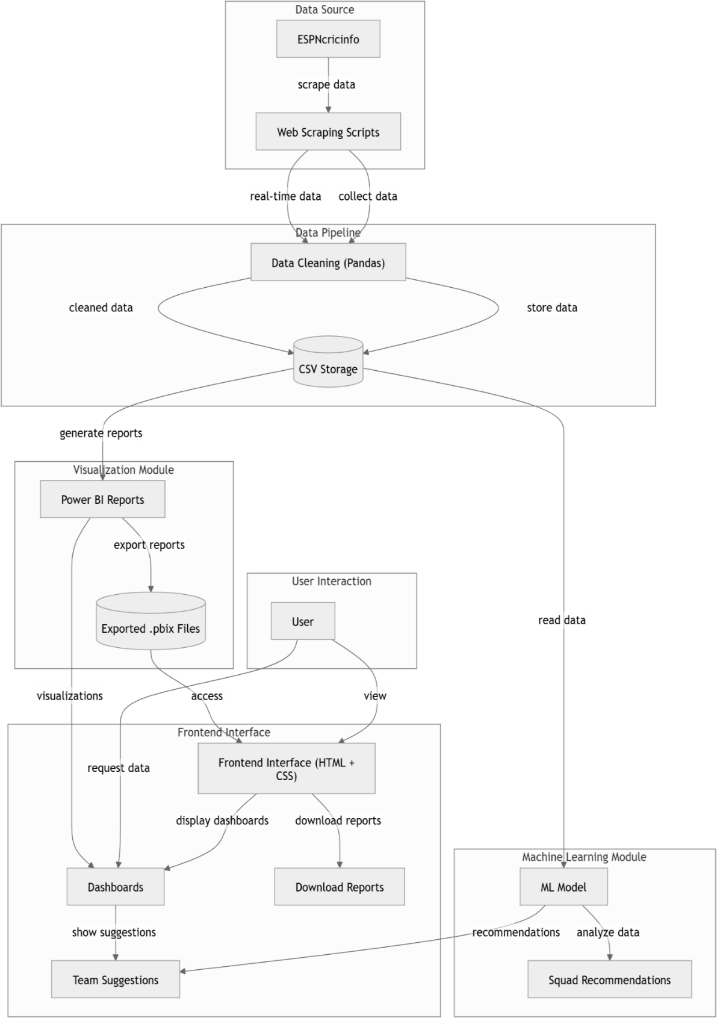
.
Figure 4.1 High Level Architecture Diagram
In this figure 4.1, the system workflow from data collection to squad prediction using ML and visual dashboards is shown.

MODULAR BREAKDOWN
The modular structure is considered the building block of any system that provides the following ability to develop, test, and deploy different modules separately. It performs different tasks in the data pipeline, with a high module cohesion and loose module coupling, thus easing debugging and making future adaptation to adding features easier. Following this is the description of the major modules:

SCRAPING MODULE
The objective of this module is to access cricket data external sources and ask for raw HTML. Retrieval of match-specific pages, player profiles, and statistical tables from the ESPN Cricinfo site is done with the use of Python libraries like requests and BeautifulSoup which simulate browser activity. The scraper is designed according to server policies with time delays between requests and user-changeable headers to minimize the possibility of blocking it. It crawls all tournament schedules, moves on to hyperlinks that link to detailed scorecards from every game played during the ICC T20 World Cup 2022.
The module is fault-tolerant with exception handling in place for failed links, timeouts, and absent elements. Further, it facilitates incremental scraping, so that it can pick up where it stopped in the event of interruptions, thus conserving time and bandwidth. As ESPN shows scores in real time, the logic to scrape should be adaptable towards the dynamic loading content with either pages paged out or JavaScript pages rendered, as necessary. In total, this module is the data ingest engine of the whole pipeline.

PARSING MODULE
The data need to be converted from semi-structured HTML to structured data in tabular forms following the scraping of data after which the parsing module comes into action. It traces important DOM nodes, which have key information like player names, runs scored, wickets taken, and economy rates, etc. This module retrieves these values and normalizes them to a standard representation that will be uniformly interpreted by downstream modules. It also resolves inconsistencies such as absent player names, anomalous structures of innings, and optional columns in scorecards.

Secondly, simple data-validation checks will have to be invoked for information to be assured correct, such that numbers fall into plausible ranges (i.e., under 500 for strike rates, overs below 20). Metadata tags can be incorporated in this parser, such as match ID, date, site, and opposing teams toward traceability right back to the originating entity. Outputted data may be available in either CSV or JSON.

STORAGE MODULE
The storage module is the core repository of all processed data. It organizes and keeps consistent schema of player statistics, match information, and historical performance records. CSVs or JSONs flat file formats for ease and portability storage can be straightforward, but more scalable solutions can use SQLite or MongoDB for advanced querying capabilities over larger datasets. This module guarantees that the data are indexed well, secured, and backed up periodically to avoid loss.
It also possesses change management functions, tracking and being able to revert changes made to the dataset. For example, if a correction is made to a player's score because of a parsing mistake, earlier versions are kept as references. In more sophisticated configurations, integration with cloud storage can be included to allow multi-user access and real-time collaboration. Storage module serves as the single source of truth for all visualization and prediction operations downstream.

VISUALIZATION MODULE
This module will convert uninformative numeric raw data to meaningful insights in an interactive form through graphs, charts, and tables. It utilizes resources such as Power BI or the matplotlib, seaborn, and plotly of Python to analyze trends of best bowlers, highest run scorers, match momentum, as well as win/loss statistics. Its dynamic visual and filtering analysis allows for granular drill-down capability for teams, players, or phases of match.
Moreover, the module will help in the exportation of dashboards in PDF or image format for reporting purposes. It allows side-by-side comparison and time series analysis enabling the grouping of like players as per their performance. To users in academia or business

PREDICTION MODULE
This module avails prediction through machine learning algorithms to future outcomes of matched results, performances by players, or even will give the best playing XIs based on historical data. This is a voluntary but very helpful module that uses machine learning algorithms to predict match results based on the past records, performance of players, or even recommend the best playing XI. Some possible algorithms that could be used include Random Forests, Logistic Regression, and K-Means Clustering to classify player roles, performance trends, or cluster players having similar capabilities. Still experimental in this framework, the module has enormous potential to impart a predictive bias to traditional analytics.
It gets input from the storage module and requires preprocessing for feature scaling and data balancing. After training, the model can be visualized for interpretability with tools such as SHAP or LIME. This module is a case in point of how this architecture can be made extensible for architectural preparedness for the contemporary methods of data science incorporation.

DATA FLOW DIAGRAM
The Data Flow Diagram (DFD) details the systematic and structured movement of data from the initial phase to the final output in the entire architecture of a project. The initial course starts where a user triggers the process with an initial command to pull data from a predefined cricket statistics source such as the ESPN Cricinfo website. This is the earliest external entity into the system, which triggers data acquisition stage from the internet, where HTML pages containing cricket-related information are fetched. The raw HTML data is passed into parsing, where important stats such as player names, scores, wickets, overs, strike rates, and others are captured, using structured logic.
Post-parsing, the raw data comes into data cleaning, with the task of filtering out inconsistencies, eliminating empty values, standardizing formats, and dealing with duplicates. This assures data of high quality and in uniformity for the next stages.
Not only for DFD to ensure that there is no redundant operation, but it would also guarantee proper data flow with no unnecessary delays or looping back. In addition, it helps identify significant interdependencies among processes, as well

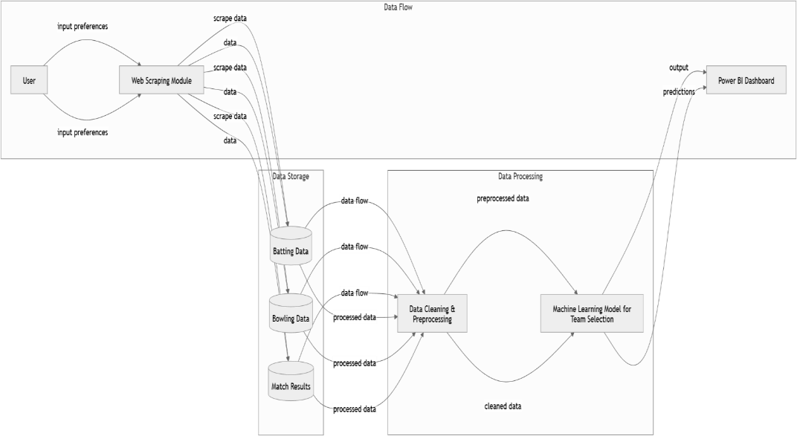
as the increased clarity in debugging or trying out certain performance bottlenecks. The DFD itself acknowledges the presence of external factors like that of internet-connectivity, thereby making apparent the expected risks during the data-fetching phase and encourages put in place of fallback systems for example caching to rerun some scraped previous data. Thus, the DFD is a design aid and is also a tool for documentation, maintenance, and plans for future scalability providing a roadmap for improvement and extension of the system.

Figure 4.3 Data Flow Diagram (DFD)

In this figure 4.3, user preferences guide the web scraping module to collect batting, bowling, and match result data, which is stored and sent for cleaning and preprocessing. The refined data is then used by a machine learning model to generate team predictions, which are visualized in a Power BI dashboard.

ENTITY RELATIONSHIP DIAGRAM
The broadly defined Entity Relationship Model or ER diagram serves as a logic blueprint for the logical structure and organization of the project's database. It exhibits all core entities involved in the working of the system: i.e., matches, players, teams, and innings - and describes how these entities are correlated through their relationships. These relationships are properly defined. Each entity is represented by a rectangle and is annotated with its attributes either inside or close to the rectangle. For example, a very important "Player" entity will have attributes such as player_id, player_name, team, batting_style, bowling_style, role, and total_runs, showing how comprehensive the details of a player, as well as their profile and statistical performances, are. The attributes in the "Match" entity which include match_id, match_date, venue, team1, team2, winner, and result_margin altogether create the definition for all elements that are vital in one single cricket match.
The ER diagram defines relationships among standalone entities. Specific relationships such as "Player Participated In Match" or "Team Played Match" or "Innings Belongs Into Match" are drawn along with cardinal figures delineated with relevant lines or connectors. For instance, in the case of Match and Innings, a one-to-many relationship would mean that one match could have several innings, but each inning belongs to only one match. In a similar way, the many- to-many relationship between Players and Matches is resolved by means of such intermediate entities as PlayerPerformance, which stores detailed statistics for every player on a match-by-match basis, i.e., runs_scored, balls_faced, wickets_taken, and overs_bowled. Such relationships not only depict the real-life interaction among cricketing entities but also aid the design of normalized and optimized data models.This is the cornerstone for ensuring referential integrity of the database, especially so when large datasets, e.g., international tournament stats, need to be handled. It also helps to optimize queries, ensuring that SQL operations like JOIN, GROUP BY, and FILTER will be executed suitably.

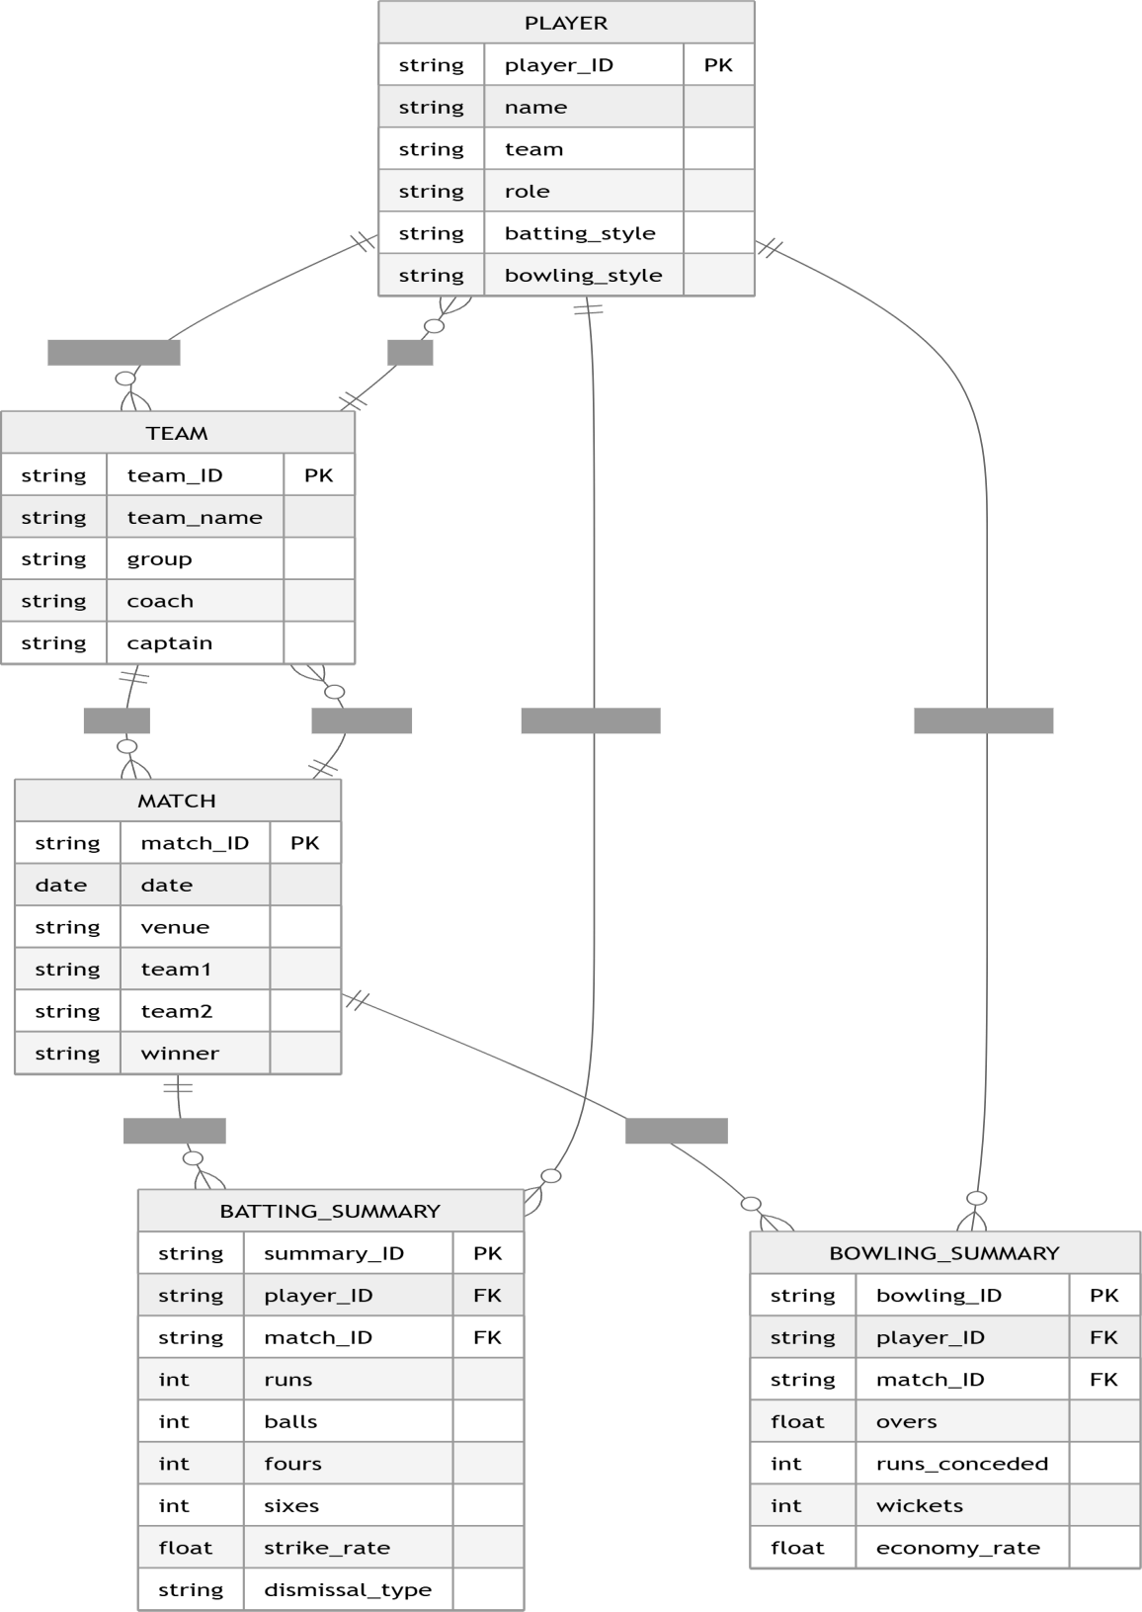

Figure 4.4 Entity Relationship Diagram (ERD)

In this figure 4.4, the ER diagram shows how players, teams, and matches are interconnected with their batting and bowling performance data

NAVIGATION FLOW
Navigation flow virtually is all about actions between users and system entities- from issuing a scraper, viewing obtained data, browsing analytics dashboards, and finally, querying best matches for such data. The user interface must be intuitive; this is why navigation flow is through command-line interfaces-to scrape data-browser-based dashboards- for visualizing and configuration files-for customization.
The navigation chart focuses on user pathways, for example picking a match ID to inspect batting performance or filtering a top 10 of wicket-takers. The design is minimal in user action, automating time-consuming tasks and being modular for developers. Even users without strong technical backgrounds can have access to rich insights through the T20 World Cup dataset.
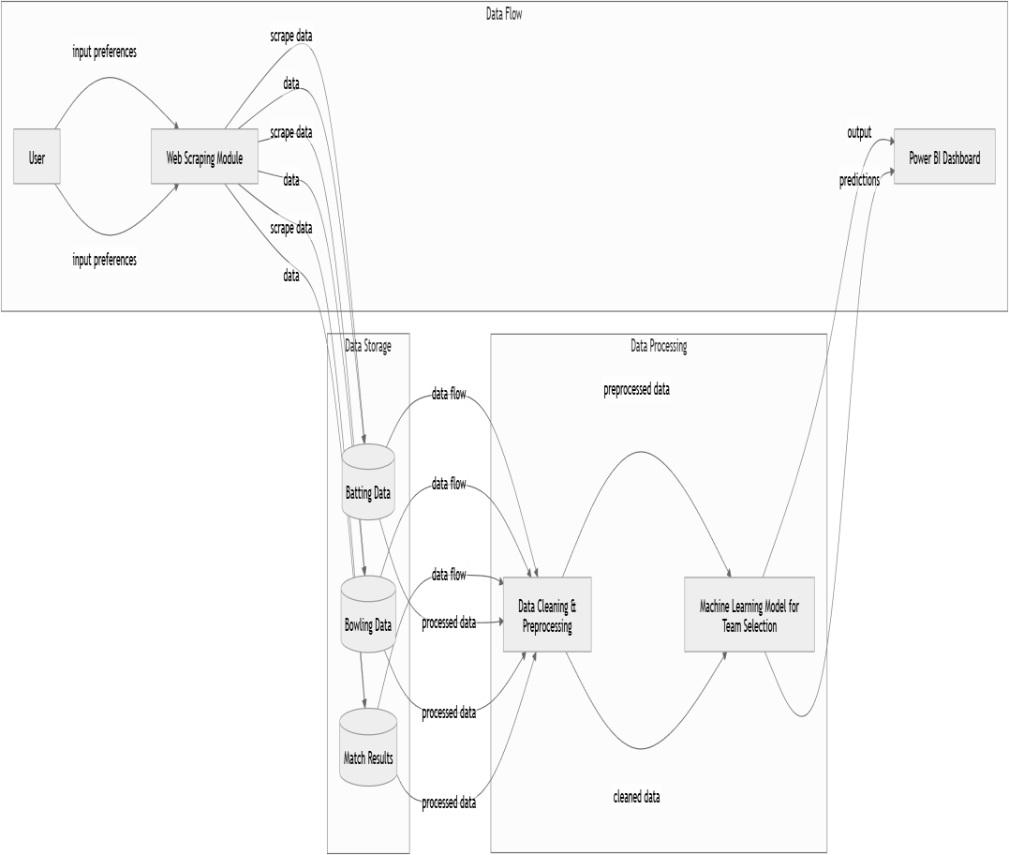

Figure 4.5 Navigation Flow Diagram
In this figure 4.5, the data flow diagram illustrates how user preferences guide web scraping to collect cricket data, which is stored and pre-processed.

CHAPTER 5 METHODOLOGY AND IMPLEMENTATION

The system approach presents an amalgamation of techniques dependent on data extraction from the web, data processing, and data visualization to create a complete system for the data analysis regarding the ICC Men's T20 World Cup 2022. The life cycle of an implementation involved some series of steps, starting with exploring data sources that were of interest, using automated mechanisms to crawl for data, then processing and organizing the crawled data that were finally displayed in a meaningful dashboard aided by interactive visualization tools. This chapter discusses each tool and technology employed along with the systematic approach adopted in scraping, data cleansing, and transformation methods.

TOOLS AND TECHNOLOGIES USED
In order to construct a strong system for real-time extraction and processing of cricket data, a range of programming libraries and tools were carefully chosen. All of these played a crucial role in making the application run smoothly and be scalable.

PYTHON
Throughout the project, Python served as the chief programming language and was the foundation on which the entire data pipeline-from scraping to transformation and export of data-stood. The elegant and readable syntax of Python permitted rapid prototyping and iterative development, a much-needed quality in a project that had semi-structured data sources that often needed modifications in logic. It was most advantageous that Python could be applied in so many ways and that it embraced multiple paradigms such as procedural, object-oriented, and functional programming, allowing seamless positioning between various stages of data handling. And an ecosystem housing thousands of open-source libraries and frameworks limiting way custom functionality had to be coded. Communication over the network was taken care of by the requests library; structured data manipulation and numeric computation were by pandas and numpy;.

BEAUTIFULSOUP
Beautiful Soup is a very useful library in Python for parsing HTML and XML code. It was crucial in traversing the complex and often nested structure of the ESPNcricinfo web pages. It was intended within the project primarily to get at the targeted information such as batting averages, bowling figures, team scores, and player profiles by traversing the correct tags, classes, and attributes within the HTML source code of the web pages. Among the web scraping libraries, BeautifulSoup stands out mostly due to its simple and intuitive syntax, fault tolerance, and adaptability to changes in layout of the webpage, which had been invaluable in creating a robust scraper.
With the parser, iterating through lists of HTML elements was straightforward, extracting text, links, and table contents, requiring a minimum of boilerplate code. This would prove especially useful while scraping multiple layers of nested data- from within scorecards or player performance tables. In addition, the approach offered by Beautiful Soup for integrating requests and lxml assisted in keeping the entire scraping effort efficient and modular. Within our project, it created a way to repackage complex, unstructured HTML into tidy Python data structures, ready for some downstream processing and analysis. It is specifically this flexibility and user-friendliness that rendered it the most indispensable asset in ensuring the accuracy and quality of raw data obtained from the web.

PANDAS
Once the data was extracted, the next level of work was organizing, cleansing, and transforming it into a tidily structured format ready for analysis; Pandas came in as the prime tool. Pandas is an open-source library in Python that is relied upon for data manipulation and introduces Series and DataFrames data structures that are very powerful. These made it possible to deal with tabular data in a manner suitable for filtering, grouping, and any kind of statistical analysis. Pandas, in the case of this project, was used for functions like converting lists of dictionaries to tables, handling missing values, renaming columns, and all the while ensuring data types consistent in every single row and column.In addition to that, it also provided tools for calculating a host of performance metrics-few of which are strike rates, economy rates, and total runs or wickets-using its built-in aggregation functions. It also facilitated more complex joins and merges across

datasets, enabling the mapping of player-level statistics with match-level summaries. In just a few lines of code, it was possible to reshape the data into formats acceptable to machine learning algorithms and data visualization platforms. By allowing the data preprocessing even more straightforward, repeatable, and auditable-Pandas is a great asset. Similarly, by being the analytical engine for transit of raw-nasty data to actionable insight, Pandas is key to the entire endeavor.

POWER BI
Power BI was employed as the topmost layer of the data pipeline, which in turn transforms processed data into insightful, interactive visualization. Recognized for its friendly UI and diversified visualization options, Power BI made it possible to use Dashboard that simultaneously presented several dimensions of data- such as batting performance, bowling trends, team comparison, and match summaries-in an integrated interface. Reports made with Power BI allow users to drill through their dashboards using slicers and filters and leverage tied dynamic charts for impact analysis hidden patterns, launching comparisons of players or even testing a team strategy against historical performance. Such an interaction is far deeper than what was found in mere static reports.
One of the advantages of Power BI is its capability to connect directly to various data sources, including CSV and JSON files, which were the output formats used in this project. Once the cleaned and transformed data was loaded into Power BI, its modeling tools allowed for the creation of relationships between datasets, calculation of KPIs using DAX formulas, and construction of visuals like bar charts, line graphs, scatter plots, and pie charts. The publishing capability to cloud or web allows interactive access and collaboration. Data precision injected through the use of Python was married with the visual storytelling capabilities of Power BI so that the raw statistics could be transformed into strategic decision- making, offering stakeholders an easy and meaningful experience..

WEB SCRAPING WORKFLOW
The process of web scraping started with identifying the said primary official source of match-data structure: that is, the official ESPN Cricinfo website where the ICC Men’s T20 World Cup 2022 is located. This choice of site was indicative of complete match coverage, standard formatting, and up-to-date results on players and statistics. The scraping journey began at the parent URL, which all match outcomes and their associated scorecard links would reference for the tournament. This represented the foundation of dynamic data extraction. The process was achieved using the requests library in Python, where GET requests were sent to the target URL and thus fetched the raw HTML content derived from the match result page. Upon receiving the response from the server, the content has been parsed using the BeautifulSoup library that allows a traversal and extraction of certain elements in the HTML structure. On close DOM structure analysis, the script isolated HTML tags and classes like <table> and <a> tags nested within result rows to isolate hyperlinks to individual match scorecards.
Once the summary URLs were captured, these were stored in a list and then iterated over, one at a time. With every scorecard page call, another GET request was made while the HTML was then parsed again to glean significant items such as team names, match dates, innings structure, and granular player-level performance. Self-explanatory batting statistics like player names, runs scored, balls faced, boundaries hit, and strike rates were extracted from structured tables that usually reside in classes like ci-scorecard-table. Here too, bowling metrics— overs bowled, runs conceded, wickets taken, and economy rates—were fetched from separate tables. The scraper was intelligent enough to differentiate between innings meant for both teams and map player performance into that particular match context. It is important, however, that user-agent headers be added to the request, so as to pose as a real browser, with the possibility of being blocked in this manner..
Besides, the construction was also in function of resilience and modularity. It specified changes in the web page structure, missing fields, and other unforeseen HTML changes, all checked under the conditional and exception- handling routines. This ensured that no scraping will stop in the middle of the work due to a malformed page or minor alterations in the layout. By modularizing it, simple debugging, testing, and reusing can happen

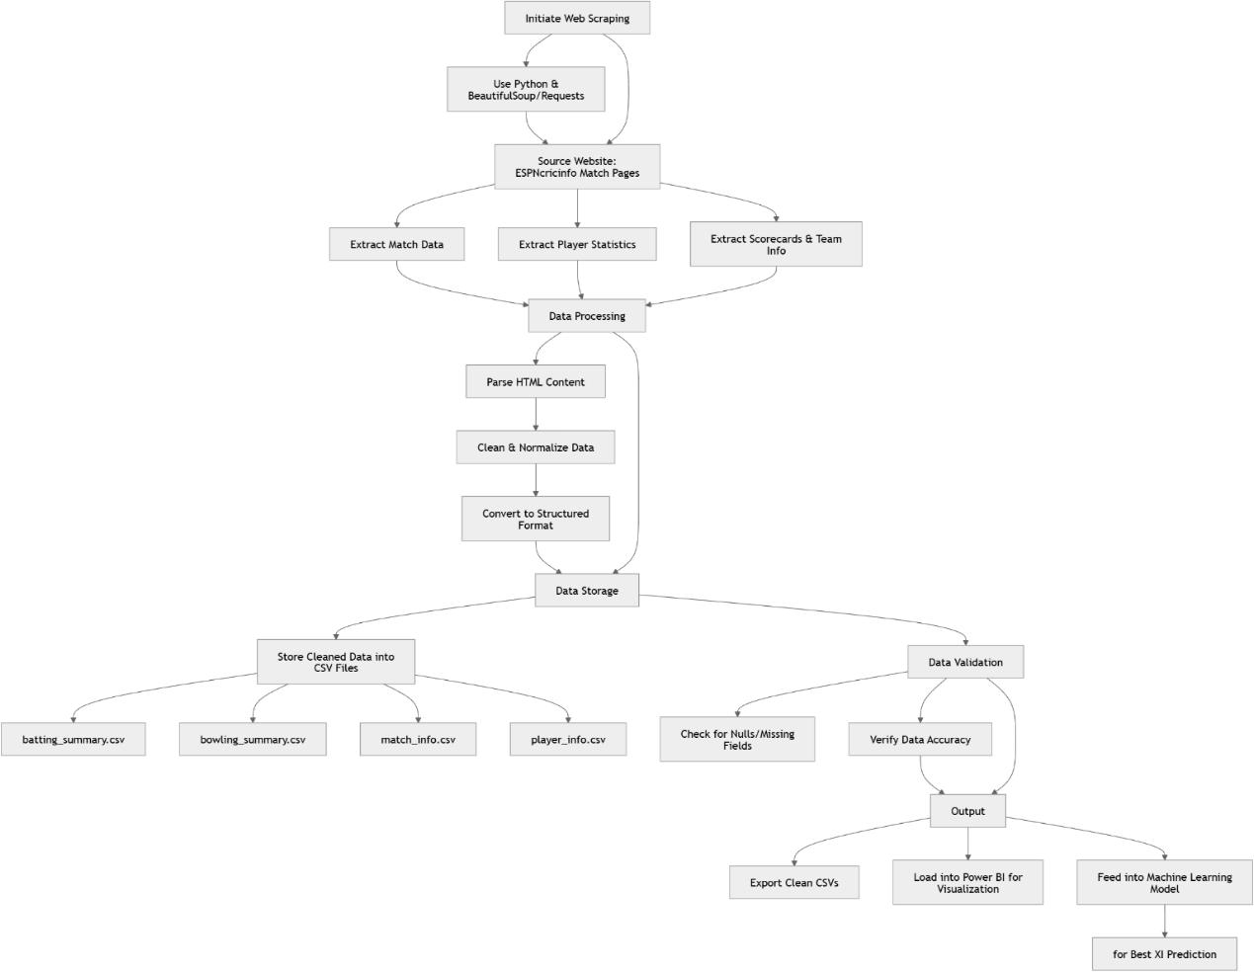

Figure 5.2 Web Scrapping Workflow Diagram

In this figure 5.2, the flowchart outlines the web scraping process using Python to extract cricket data from ESPNcricinfo, followed by data cleaning, structuring, and storage in CSV files. The validated data is then used for visualization in Power BI and fed into a machine learning model for best XI prediction

DATA CLEANING & PREPROCESSING
The data obtained from the web scraping processes is often polluted and inconsistent. The project thus educated itself about a good number of cleaning and preprocessing steps to bring the raw HTML into structured analyzable datasets. Actions included whitespace-trimming, case normalization, stripping of special characters, and deletion of irrelevant rows like extra and total score summary rows from tables. Data entries that contained missing or malformed values were flagged and handled with conditional checks and fallback measures. A consistent type for each data entry was enforced—for example, run values were converted from string to integer type and normalized batting positions. Player names were also trimmed and normalized in a constant format to further assist in grouping and analysis during later stages. The next step involved restructuring the cleaned data into dictionaries and dataframes having schemas fitting several matches, innings, and player-year predictions.

JSON & CSV CONVERSION
After the cleanup of the data, the structured records were converted into JSON and CSV formats. The JSON format was chosen to create a lightweight hierarchical structure to store nested data in this case, a player's performance in the context of a match. Its flexibility makes it easy to integrate into web dashboards or APIs in subsequent iterations of the project. The CSV format, however, was chosen for compatibility with established data analysis tools such as Excel, Power BI, and even R. We paid particular attention to encoding, delimiters, and schema compatibility throughout this transaction in order to prevent integration challenges that crop up later. All records were also tagged with match metadata, team affiliations, and innings identifiers so that the context is maintained. These exported files were the final structured datasets in readiness for visual analysis and modeling.

INTEGRATION INTO DASHBOARD
This last section of the project was by far the best, integrating the cleaned dataset into a visual analytics dashboard using Power BI. The exported CSV files were fed into Power BI as datasets, where relationships were established between the match details, batting summaries, and team level data tables. The visualizations

were developed to showcase leading scorers, strike rates, batting depth per match, inter-team comparisons, and player consistency across matches. Interactive filters and slicers allowed the audiences to drill down into the data by teams, players, or match dates. Attention was given to the choice of color, chart type, and placement to ensure that the visualizations were both clear and appealing. The dashboard aims to cater to both casual viewers and cricket analysts through overviews and micro-details from one workspace.

SAMPLE CODE AND OUTPUT
To demonstrate the implementation, some sample code snippets have been added, in which primary steps of the preprocessing and scraping pipeline are shown. These code blocks cover match URL extraction, scorecard tables parsing, player row filtering, and dictionary construction for JSON output. The JSON output file contains an array of objects that represent a player's performance with keys for runs, balls faced, strike rate, number of boundaries, and dismissal type. These example outputs correspond with real foreign class time data that is sourced directly from ESPNcricinfo and serves as source input to visualization. With sufficient in-code commenting and modularization, the code has remained simple to maintain and extend in that further metrics, such as bowling performance or player ranking, can be included with minimal overhead.

CHAPTER 6 RESULTS AND VISUALIZATION

Analysis of the data from the ICC Men's T20 World Cup 2022 has yielded broad insights through the application of data processing, statistical methodologies, and visualization techniques. This chapter aims to describe in an organized manner the findings of the sub-studies in various areas of the tournament such as batting, bowling, and comparisons from the team perspective. Each of the subsections in the current chapter signifies important findings and patterns being presented through graphs, charts, and interactive dashboards.

BATTING SUMMARY INSIGHTS
The batting summary statistics are a valuable resource for the identification of performance trends between players and teams. The analysis was organized around important statistics like strike rate, consistency, and aggregate runs.

STRIKE RATE TRENDS
One of the important statistics in T20 cricket is strike rate since it takes into account the speed with which a batsman is able to accumulate runs—something that is key in the shortest and fastest format of the game. In this project, the strike rate was calculated for each player using the standard formula of runs scored divided by balls faced multiplied by 100, which provided a measure of the efficiency with which they could score runs. Analysis using line and bar charts revealed that top-order batsmen maintained strike rates above 130 consistently, showcasing their ability to rotate strike and build partnerships, while middle-order and finishing batsmen would often have strike rates above 150, thus allowing them to enhance the score during the death overs. Such trends point to differences in the strategies adopted for batting roles, either the openers trying to lay a good foundation and farm the strike or finishers trying to score in quick bursts of high impact under pressure. Heat maps would illustrate the distribution of strike rates in various matches and conditions thereby facilitating the identification of consistent performers and a degree of situational adaptability. With these heat maps and time-series analyses, it was shown how individual players would change their scoring patterns depending on match situations,

opposition, and phase of play. This further assessment of the dynamics of strike rate has contributed to a better understanding of player value as well as more informed decisions.
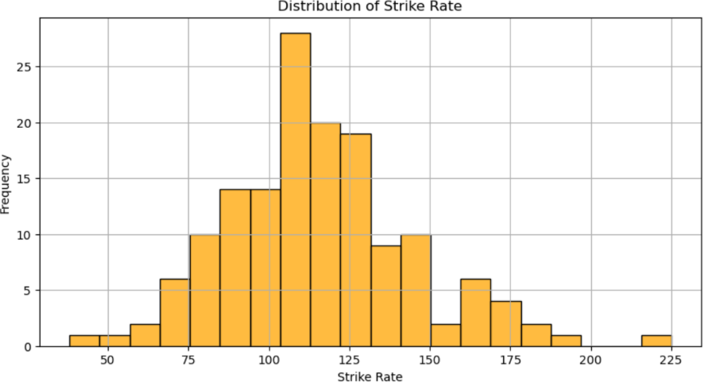
Figure 6.1 Strike Rate Trends of Top Batters

In this figure 6.1, the histogram shows the distribution of strike rates, with most values concentrated between 90 and 130, indicating a right-skewed pattern.

CONSISTENCY OF LEADING PLAYERS
Consistency was measured through two primary indicators: number of 30+ scores and standard deviation of runs per match. Low standard deviation reflected stable contributions, whereas regular high scores reflected impact players.Players such as Suryakumar Yadav and Jos Buttler showed great consistency, often scoring more than 40 in a number of games. This was depicted through box plots and player-specific performance curves. These images not only presented a summary of runs scored but also put performance into context depending on match situations and opposition.

BOWLING SUMMARY ANALYSIS
Bowling statistics like economy rate, strike rate, and total wickets taken provide essential information about a team's overall bowling efficiency and defence mechanisms. These metrics help to discover and find bowlers who consistently

restrict runs as well as taking key wickets under pressure. The project, meanwhile, treats each innings as a separate situation in order to provide a complete picture of situational performances, showing how different bowlers perform across various contexts of a match. The tracking of consistency in a match-by-match manner would therefore help to reveal those unusual individual performances. Cumulative performance reports have, on the other hand, shown how these trends appeared over the long haul and helped examine the strength of an entire team both at the tournament and within the economy rate. The economy rate is a major indicator that shows how much well a bowler could constrain the scoring, while the strike rate tells how often wickets should be taken. Together, these statistics guide team management in understanding the impact of bowlers beyond their averages. The above project extracts from raw scorecards the data required for economy rate, strike rate, and total wickets through Python's data manipulation tools. The data is then visualized in Power BI for comparative analysis across teams and bowlers. The bowling analytics division is, however, the backbone with respect to performance appraisal under fielding and the decisions related to team selection and strategies.

ECONOMY RATE LEADERS
To find those bowlers who were successful in strangling scoring, the economy rate based on runs given per over played a vital role. Analysis reveals that bowlers with economy rates of less than 6.5 often turned the tide in very close matches. These bowlers had created constant pressure that forced opposition batters into errors. Leaderboards and scatter plots provide a visual analysis of the top-performing players across many teams. Spinners had often been the economy leaders, perhaps most so at the middle overs when run flow control means the most. They usually operate on slower pitches with a lot of variation in pace and length. Violin plots displayed the economy rates distinguishing match phases and pitch types, thereby indicating the major variation by bowler's impact. These plots highlighted conditions pertinent to a bowler's ability to maintain a tight economy in various match situations

WICKETS ACROSS MATCHES
Total wickets served as the most major criterion of judging how effective the strike bowlers were at each level of the tournament. Their aggregative match-by- match record of wickets also enabled internal analyses regarding breakthrough bowlers who played vital roles in break momentum. Such players made crucial shifts in matches and were often the backbone of their teams' successes. Timeline bar charts were used to best visualize each bowler's wicket haul match- wise to illustrate performance trends, hot streaks, and game-defining spells. Such visualizations bring massive patterns into sight regarding consistency and impact - especially when the stakes are highest. For instance, Sam Curran and Wanindu Hasaranga were two major performers in that profile; they repeatedly broke key partnerships and performed under pressure. Their emergence in such crucial times made them valuable assets to turn tightly contested matches. The impact of such performances was understood in numbers and text with the tournament narrative. When viewed against game contexts, expense insights painted a richer picture of how these bowlers turned proceedings. The combination of quantitative and qualitative perspectives improved the process by which data would be interpreted and provided a more holistic understanding of match dynamics. This union of numerically evidenced claims and cricket moments would create much broader storytelling potential for the project.

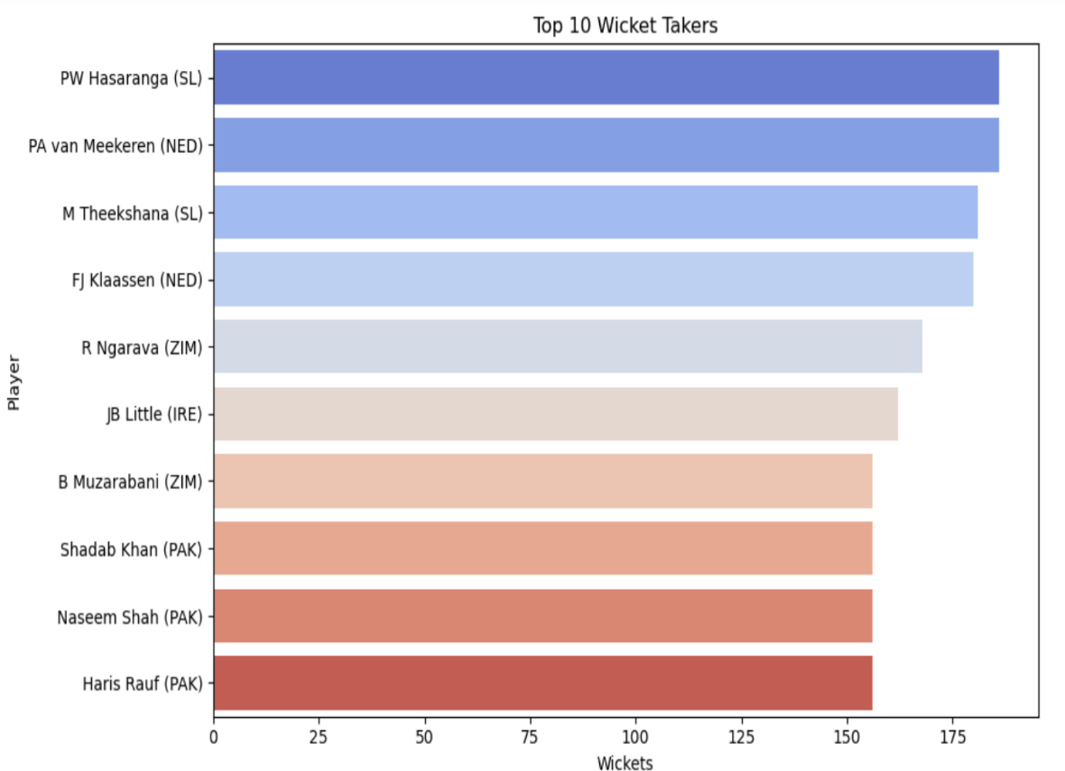
Figure 6.2 Player Consistency Box Plot
In this figure 6.2, a horizontal bar chart displays the top 10 wicket takers, with PW Hasaranga leading the list with the highest number of wickets.

TEAM COMPARISON METRICS
Title aggregates and contrasts aggregated team performance metrics. Average runs per match, average wickets lost, net run rate, and boundary ratios were compared using bar diagrams and radar graphs.Such metrics would be helpful in cross-team comparisons to suggest trends on comparative strategies. For example, England and India relied heavily on scoring more runs, while Sri Lanka and Zimbabwe had a stronger dependence on their bowlers. It also included a graph for win-loss ratios and average performance per phase of play (Powerplay, Middle Overs, Death Overs).

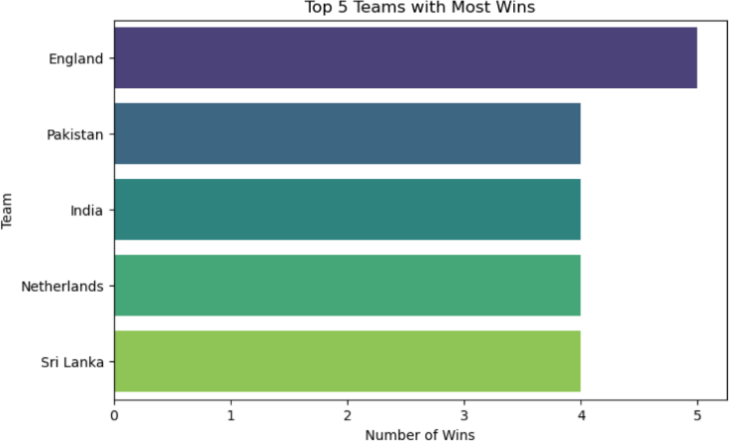

Figure 6.3 Team Comparison Chart

In this figure 6.3, a horizontal bar chart highlights the top 5 teams with the most wins, with England leading with 5 victories.

TRENDS AND HIGHLIGHTS
Despite the plethora of match data, a trend-and-key-performance-wised exploration into ICC Men's T20 World Cup 2022 threw out some mesmerizing insights. This study analysis transformed the raw data from scorecards into structured and visualized alternatives, showcasing individual brilliance, team dynamics, and tournament-wide patterns that shaped the results of match outcome matches.
One of the trendier trends found within the batting dataset was that strike rate supplanted sheer aggregate runs-more runs. A player had a significantly lower total number of runs but quite a heavy strike rate, which had much more influence in the situations higher on pace during death overs. This tendency proved that

usually, then long innings, it was the fire in high-impact batting that shifted balances. Similarly, batsmen keeping the ball flying with 4s and 6s at that critical moment changed the momentum, especially in the powerplay overs.
In bowling, economy created stronger conditions than most wickets alone. Run contagion has produced pressure towards possible dismissals from the opposite end. Dot ball particularly matters in low-scoring games; analysis shows whether bowlers produce more dot balls, which corresponds to success rates within those teams. In addition, spinners during the middle overs can cause huge damage to choking run flow, which has built the increasing importance in bond with wrist and finger spinners for T20 form.
At the team level, consistency with the top order combined with consistent death- over finishers is characteristic of the most successful squads. The top performing teams were balanced in their contributions across the batting order as opposed to relying on one or two star players. Even match summaries suggested that teams that defended totals with bowlers who maintained a sub-7 economy rate during the first ten overs won a larger percentage of matches.
Other than this, one interesting feature of the project has been establishing a kind of "Best XI" squad based on performance metrics-a feature where machine learning selects the best possible combination of players across roles-batsmen, bowlers, all-rounders, and wicket-keepers. The way this approach works is automated, which ensures objectivity and, at the same time, provides a reproducible framework that can be extended to other tournaments or even to hypothetical match simulations.
The dynamic Power BI presentations that are fed into this visualization layer provide an intuitive, attractive, and visual picture performance trend comparisons and outliers related to a player versus player comparisons, match timelines, role- based filters heatmap of team performance across venues. These visuals are not only enhancing user experience but also equip coaches-analysts and fans with a pickup symbolized essence of complex datasets.
What the project proves is that data can be structured and visualized smartly, bringing cricket analytics to life. It tells the story of making traditional stat reporting dynamic, interactive performance intelligence and turns into a powerful tool for the casual cricket fan and also the professional strategist.

INTERACTIVE DASHBOARD OVERVIEW
An interactive dashboard within Power BI was created with live-data interfaces and significantly enhanced usability in real-time data analysis. Major dynamic filters within the dashboard were included on player names, teams, and dates of matches. Slicers, of interactive type, and an inbuilt drill-down functionality enable users to access summaries at an incredibly granular level with respect to batting and bowling, letting one explore patterns without writing code.
The dashboard had:
•Dynamic leaderboards for the highest scorers and wicket-takers
•Heatmaps on team performance over time
•Probabilistic match result predictors based on historical data
•Filtered performance based on stadium and pitch type
This visual interface links technical research with easy navigation suitable from analysts to the casual fan.

INTERPRETING THE GRAPHICS
In fact, each visual representation was made to have a corresponding comment or annotation, like a kind of framing for interpretation. Instead of presenting trends, we describe why we expect them to be so. An example is the high boundary percentage of some players, associated with match pressure and the role's expectations.
Color codes were selected for easy differentiation of categories, and annotations were used to highlight anomalies or peak performances. The choice of visuals was made carefully, depending on the insight being presented — i.e., line plots for time-based data, scatter plots for correlation, and heatmaps for frequency analysis.
Interpretations provided insight into:
•Form of players throughout the tournament
•Momentum shifts in matches
•Opposition-themed strategy
•Venue on performance

EXPORTS & RESULTS SHARING
Visually and processed data were exported in many formats for distribution and future use:
•Example: Raw and processed data CSV and excel files.
•All major visualizations are now captured in PNG and PDF formats.
•Power BI dashboards brought up online for dynamic use.
•A GitHub repository of scripts and data for reproducibility.
Such an export system guaranteed transparency while greatly simplifying further integration into future analytic flows or presentationsThis way, it became possible for collaborators and reviewers to check methods and investigate other interpretations.

CHAPTER 7 CONCLUSION AND FUTURE SCOPE

A final word on this project would be to say that it made a sincere attempt on the pathway of cricket analytics and data science to come together under a structured paradigm. Data scraping, processing, and analysis on real match data from the ICC Men's T20 World Cup 2022 not only confirmed the feasibility of data-driven narratives in the sporting field but also created a scalable platform for any forthcoming analytical pursuits. This chapter talks about the main achievements and limitations of the project and outlines several potential enhancements that could increase its value and technical capability in the future..

CONCLUSION:
The project "Pitch Perfect: Data-Driven Predictions for the Best Cricket Squad" effectively portrays the strong convergence of sports and data science. Using actual T20 World Cup 2022 data, this system highlights how smart data processing, visualization, and machine learning methods can be used to make more intelligent team selection choices. The methodology included web scraping of player and match data from ESPNcricinfo, complete data cleaning, transformation, and analysis using Pandas and BeautifulSoup Python libraries, and then structuring the data and visualizing it in Power BI to make informative dashboards that identify performance trends, strike rate effectiveness, bowling economy, and match results.
In addition, the project incorporates machine learning models for predicting a best-playing XI through weighted performance indicators. This data-driven, automated team suggestion defeats the incapability of manual analysis and intuitive selection, providing a more sustainable and replicable option. The implemented system guarantees transparency, reproducibility, and flexibility for future competitions through parameter and model tuning.
Though the project shows healthy initial metrics, it also lays groundwork for additional features like real-time match data integration, more in-depth player analyses through AI, and creating a fantasy cricket interface

SUMMARY OF ACHIEVEMENTS
A consolidated organized execution plan led to many of the principal objectives being attained in the following contexts:
•Successful Web Scraping: Match data relevant to our study was successfully scraped from publicly available sources via Python libraries such as requests, BeautifulSoup, and pandas with minimal errors.
•Data Preparation and Cleaning: The raw data scraped was converted into clean CSV structures for downstream analysis purposes after lots of procedure involving cleaning, normalization, and feature engineering.
•Insightful Analysis: Some descriptive analysis was carried out and various statistical summaries were generated such as batting strike rates, leading wicketers, economy leaders, performance trends by team, etc. These gave clear insights into player consistency, team dominance, and match dynamics.
•Interactive Visualization: An intuitive and interactive dashboard was created in Power BI with dynamic filtering for matches, players, and statistics, thus allowing stakeholders to dig into insights without code-level involvement.
•Best XI prediction base: An elementary building block for predicting the best playing XI was done by elementary player metrics. This sets the stage for the future introduction of machine learning models.
All these collectively constitute a robust sports domain-specific data analysis pipeline with technical relevance as well as relevance to the domain in question.

PROJECT SHORTCOMINGS
However laudable, this project was not without its limits, which must be stated so that a fair estimation can be made:
•Static Data: Analysis was from historic tournament data and does not show current or future changes in performance by players or strategy by teams.
•Restricted Feature Set: Certain advanced cricket statistics regarding pitch conditions, strike zone mapping, or fatigue levels of players weren't included, all due to limitations posed on scraping data only from one or two sources.
•Prediction Simplicity: The predictor of the playing XI was statistical and rule- based, with no inclusion of advanced algorithms that would take into account context-based decisions such as form, match condition, and opposition history.
•Manual Updates: The system, as it stands, doesn' auto update on fresh match

data or refresh schedules, thereby limiting its long-term use unless hand updated.
•Dashboard Sharing: Power BI dashboards need to be installed locally or shared through paid services for extended access, which might restrict its availability to non-technical users.
Such limitations form a basis for improvement and innovation.

MACHINE LEARNING INTEGRATION POSSIBILITIES
The next apparent sequel for development in this project is the involvement of Machine Learning for predictive and prescriptive purposes. Predicated on sufficient historical match data, the following are looked at in terms of likely ML applications:
•Player Performance Prediction: Performance of players in the future (runs or wickets in future matches) can be predicted using classification or regression methods (including Random Forest, XGBoost) based on past match data, opposition, venue, etc.
•Win Probability Estimation: Based on toss results, team compositions, etc., ML could be trained to forecast match outcomes based on pre-match data.
•Dynamic Team Selection: Metaheuristic optimization techniques including Genetic Algorithms or Reinforcement Learning for constructing context-specific playing elevens based on pitch, weather, and opponent analysis.
•Clustering for Player Profiles: By exploring the particulars of players through unsupervised tactics, we may derive types of players such as "power hitters," "death-over specialists," or "anchor players."
If models of this sort are implemented, the system transforms itself from being merely descriptive to predictive intelligence.

ADDITION OF LIVE MATCH DATA
Incorporation of live match data can be extremely value-additive and useful in the system. Some areas of application would emphasize real-time updating of dashboards, tracking of player statistics in real time, and even real-time analytics during mid-game.
To achieve this, scraping scripts/APIs will have to be scheduled for periodic execution, pouring live data streams into persistent databases. It will also require

setting up automation logic using Power BI Dataflows, CRON jobs, or Airflow. Additionally, live visualizations, such as "Live Run Rate," "Current Partnership Impact," and "Wickets to Fall Next," would be exciting real-time experiences.

FANTASY TEAM GENERATOR POSSIBILITIES
A useful application evolved over this platform will be a Fantasy Team Generator for fantasy cricket websites like Dream11 or MPL. This application would suggest optimal combinations of players based on:
•Player form at present
•Weakness of the opposing team
•Conditions of the match
•Player credits and budget limits
The system could use optimization algorithms like Knapsack Problem Solvers or Integer Linear Programming (ILP) to arrive at the most performing team with given constraints of credits and player roles (e.g., at least one wicket-keeper, 4 bowlers, etc.).
Furthermore, user preferences (e.g., "prefer all-rounders" or "avoid injury-prone players") could make this tool highly personalized and competitive.

REAL-TIME API INTEGRATION
The best scalable improvement would be enabling real-time APIs from cricket data providers like CricAPI, SportRadar, or CricketData.org. By substituting web- scraping with structured APIs:
    - Accuracy and consistency in data are enhanced tremendously.
    - Real-time stats become possible.
    - There is a reduction in redundant data cleaning.
    - Error handling becomes simpler, thanks to well-defined schemas.
It also safeguards the system from future changes to formats or newer datasets such as women's cricket, Under-19 competitions, and franchise leagues.
RESTful APIs can easily be implemented through Python's requests or even using more advanced frameworks like FastAPI to build microservices that can send this data straight into dashboards or web applications..

FUTURE SCOPE:
The future horizon of the project "Pitch Perfect: Data-Driven Predictions for the Best Cricket Squad" is full of possibilities for growth, innovation, and practical application. With cricket further developing with a high focus on analytics and performance-based decision-making, this project can be greatly improved to suit contemporary needs. One of the most noticeable future additions involves the incorporation of real-time data feeds via APIs, which would enable the system to retrieve live statistics from currently running matches and dynamically update player performance metrics. This would provide coaches and analysts with the ability to make decisions based on the latest and most relevant information. Moreover, more sophisticated machine learning algorithms like Random Forests, Gradient Boosting, or even deep networks can be integrated to further improve the prediction of the optimal playing XI, providing more accurate insights based on intricate, non-linear relationships among variables.Yet another vital area of development in the future includes integrating extra player parameters like fitness records, injury data, psychological assessment, and training performance, all obtainable from wearables and IoT devices.
The system would then be able to evaluate readiness at the player level, and not merely statistically, by utilizing such data points. This would prove extremely useful in situations where physical health influences readiness for the match. In addition, the model can be generalized to support various cricket formats such as ODIs and Test matches, and hence it becomes more flexible and accessible across a wider set of use cases. The system can also be developed to support opposition-based team optimization in which the playing XI is chosen considering opponent vulnerabilities, pitch conditions, and weather updates. To attract a broader audience, particularly cricket enthusiasts and fantasy league gamers, the website can add a fantasy cricket suggestion engine. It would not only create ideal squads for actual games but also propose fantasy teams as per individual users' preferences and scoring systems.
An interactive dashboard-based interface can be built into a web or mobile app with simple navigation, player comparison features, filters, and report and visual export options. User-driven validation mechanisms can also be implemented, enabling coaches, analysts, and fans to provide feedback on the suggested squads, which can be used to enhance the machine learning model using

reinforcement learning. As information continues to increase in value and accessibility, the system can morph into a full-fledged cricket analytics package, providing tactical as well as strategic insights that transform the manner in which teams are constituted as well as games are tackled

REFERENCES

[1.] B. Hassan, C. Clough, Y. Siddiqi, R. Faizan Ali and M. A. Arshed, "PlayerRank: Leveraging Learning-to-Rank AI for Player Positioning in Cricket," in IEEE Access, vol. 12, pp. 177504–177519, 2024, doi:10.1109/ACCESS.2024.3495528.Keywords: Sports Machine Learning; Accuracy; Prediction Algorithms; Machine Learning Algorithms; Deep Learning; Random Forests; Performance Analysis; Cricket Player Prediction; Ranking Algorithms; Learning to Rank.

[2.] Z. Pu et al., "Orientation and Decision-Making for Soccer Based on Sports Analytics and AI: A Systematic Review," in IEEE/CAA Journal of AutomaticaSinica,vol.11,no.1,pp.3–72024, doi:10.1109/JAS.2023.123807.Keywords:Tracking Loops; Systematics; Decision-Making; Taxonomy; Virtual Environments; Reinforcement Learning; Benchmark Testing; AI; Sports Analytics.

[3.] M. Soloviev, P. Aksenov, A. Skhvediani, T. Tenishev, F. Kolomenskiy and
E. Bormontova, "Text Mining-Based Analysis of Content Topics and User Engagement in University Social Media,"in IEEE Access, vol. 12, pp. 150354–150371, 2024, doi:10.1109/ACCESS.2024.3474794.Keywords:
Social Networking; Stakeholders; Decision Making; Analytical Models; Sentiment Analysis; Data Visualization; Topic Modeling; University Media.

[4.] C. Mou, "The Attention Mechanism Performance Analysis for Football Players Using the Internet of Things and Deep Learning," in IEEE Access, vol.12,pp4948 4957,2024,doi:10.1109/ACCESS.2024.3350036.Keywords:
Sports Sensors; Big Data; Analytical Models; IoT; Deep Learning; Attention Mechanism; Football Player Performance.

[5.] J. Liu et al., "PoseCoach: A Customizable Analysis and Visualization System for Video-Based Running Coaching," in IEEE Transactions on Visualization and Computer Graphics,vol.30,no.7,pp.3180–3195, 2024, doi:10.1109/TVCG.2022.3230855.Keywords: Video Processing; Sports

Data Analysis; Three-Dimensional Displays; Human Pose Estimation; Data Visualization.

[6.] Cao et al., "Team-Builder: Toward More Effective Lineup Selection in Soccer," in IEEE Transactions on Visualization and Computer Graphics, vol.29,no.12,pp.51785193,2023,doi:10.1109/TVCG.2022.3207147.Keywo
rds: Sports Visualization; Lineup Selection; Trajectory Analysis; Computational Modeling; Visual Analytics.

[7.] G. Annino et al., "Assessing Sports Performances Using an Artificial Intelligence-Driven System," 2023 IEEE International Workshop on Sport, TechnologyandResearch(STAR),Cavalese,Trento,Italy,2023,pp.98103,doi
:10.1109/STAR58331.2023.10302647.Keywords: Biomechanics; Stereo Image Processing; Pose Estimation; Sport Assessment; Video Analysis; Tennis; Water Polo; Roller Skating.

[8.] F. Wu and H. Chen, "The Analysis of Technical Characteristics of Badminton for Sports With Neurorobotics Under Machine Learning," in IEEEAccess,vol.11,pp.–144348,2023,
doi:10.1109/ACCESS.2023.3345636.Keywords: Neurorobotics; CNNs; Badminton Action Feature Extraction; Machine Learning; Binocular Vision.

[9.] Z. Ziyi, R. Bunker, K. Takeda and K. Fujii, "Multi-Agent Deep-Learning Based Comparative Analysis of Team Sport Trajectories," in IEEE Access, vol.11,pp.4330543315,2023,doi:10.1109/ACCESS.2023.3269287.Keywor
ds: Multi-Agent Systems; Trajectory Analysis; Machine Learning; Unsupervised Learning; Team Sports.

[10.] Anik, S. Yeaser, A. G. M. I. Hossain, and A. Chakrabarty, "Player’s Performance Prediction in ODI Cricket Using Machine Learning Algorithms,"Proc.4thInt.Conf.Electr.Eng.Inf.Commun.Technol.(iCEEiCT),2 018,pp.500505.Available:https://ieeexplore.ieee.org/abstract/document/86 2811.Keywords:Player Performance Prediction; Machine Learning; Random Forests; Decision Trees; ODI Cricket.

APPENDIX
A1 – SOURCE CODE

WEB SCRAPING
BATTING SUMMARY
from bs4 import BeautifulSoup import json
with open("C:/Users/shake/OneDrive/Documents/t20_wc1.html", "r", encoding="utf-8") as file:
soup = BeautifulSoup(file, "html.parser") table = soup.find("table")
if not table:
print("❌ Table not found. Make sure you pasted full table HTML.") else:
rows = table.find_all("tr")[1:] batting_summary = []
for row in rows:
cols = row.find_all("td") if len(cols) >= 15:
player = {
"Player": cols[0].text.strip(),
"Team": cols[1].text.strip(),
"Mat": cols[2].text.strip(),
"Inns": cols[3].text.strip(),
"NO": cols[4].text.strip(),
"Runs": cols[5].text.strip(),
"HS": cols[6].text.strip(),
"Ave": cols[7].text.strip(),
"BF": cols[8].text.strip(),
"SR": cols[9].text.strip(),
"100": cols[10].text.strip(),
"50": cols[11].text.strip(),
"0": cols[12].text.strip(),
"4s": cols[13].text.strip(),

"6s": cols[14].text.strip()
}
batting_summary.append(player)
with open("t20_wc_batting_summary.json", "w", encoding="utf-8") as json_file:
json.dump(batting_summary, json_file, indent=4)
print("✅ Data extracted and saved to t20_wc_batting_summary.json")

ML PREDICTION
import pandas as pd import numpy as np
from sklearn.preprocessing import MinMaxScaler
players = pd.read_csv('c:/Users/shake/Downloads/data-analytics-project-for- beginners/t20_csv_files/t20_csv_files/dim_players.csv')
batting = pd.read_csv('c:/Users/shake/Downloads/data-analytics-project-for- beginners/t20_csv_files/t20_csv_files/fact_bating_summary.csv')
bowling = pd.read_csv('c:/Users/shake/Downloads/data-analytics-project-for- beginners/t20_csv_files/t20_csv_files/fact_bowling_summary.csv') batting_stats = batting.groupby('batsmanName').agg({
'runs': 'sum',
'balls': 'sum',
'4s': 'sum',
'6s': 'sum', 'match_id': 'nunique'
}).reset_index()
batting_stats.rename(columns={'match_id': 'batting_matches'}, inplace=True) batting_stats['batting_avg'] = batting_stats['runs'] / batting_stats['batting_matches']
batting_stats['strike_rate'] = (batting_stats['runs'] / batting_stats['balls']) * 100 bowling_stats = bowling.groupby('bowlerName').agg({
'wickets': 'sum',
'runs': 'sum',
'overs': 'sum', 'match_id': 'nunique'

}).reset_index()
bowling_stats.rename(columns={'match_id': 'bowling_matches'}, inplace=True) bowling_stats['economy'] = bowling_stats['runs'] / bowling_stats['overs'] bowling_stats['bowling_avg'] = np.where(
bowling_stats['wickets'] > 0, bowling_stats['runs'] / bowling_stats['wickets'], 999
)
complete_stats = players.merge(batting_stats, left_on='name', right_on='batsmanName', how='left').merge(
bowling_stats, left_on='name', right_on='bowlerName', how='left', suffixes=('_batting', '_bowling'))
complete_stats = complete_stats.fillna(0) scaler = MinMaxScaler()
batting_features = ['batting_avg', 'strike_rate'] complete_stats[batting_features] = scaler.fit_transform(complete_stats[batting_features])
boundary_stats = complete_stats[['4s', '6s']].sum(axis=1).values.reshape(-1, 1) normalized_boundaries = scaler.fit_transform(boundary_stats) bowling_features = ['wickets', 'economy']
complete_stats[bowling_features] = scaler.fit_transform(complete_stats[bowling_features]) complete_stats['batting_score'] = (
complete_stats['batting_avg'] * 0.3 + complete_stats['strike_rate'] * 0.3 + normalized_boundaries.flatten() * 0.4
)
complete_stats['bowling_score'] = ( complete_stats['wickets'] * 0.4 +
(1 - complete_stats['economy']) * 0.3 +
(1 - (complete_stats['bowling_avg'] / complete_stats['bowling_avg'].max())) * 0.3
)
def select_players(df, role, n, sort_by='batting_score'):

return df[df['playingRole'].str.contains(role, na=False, case=False)].nlargest(n, sort_by)
best_wicketkeeper = select_players(complete_stats, 'Wicketkeeper', 1, 'batting_score')
best_batsmen = select_players(complete_stats, 'Batter|Order', 4, 'batting_score')
best_allrounders = select_players(complete_stats, 'Allrounder', 2, 'batting_score')
best_bowlers = select_players(complete_stats, 'Bowler', 4, 'bowling_score') best_eleven = pd.concat([best_wicketkeeper, best_batsmen, best_allrounders, best_bowlers])
def format_stats(row):
matches = max(row['batting_matches'], row['bowling_matches']) return {
'Name': row['name'],
'Team': row['team'],
'Role': row['playingRole'], 'Matches': int(matches),
'Runs': int(row['runs_batting']) if 'runs_batting' in row else 0,
'Batting Average': round(row['runs_batting'] / row['batting_matches'], 2) if row['batting_matches'] > 0 else 0,
'Strike Rate': round(row['strike_rate'], 2), 'Fours': int(row['4s']),
'Sixes': int(row['6s']),
'Wickets': int(row['wickets']) if 'wickets' in row else 0, 'Economy': round(row['economy'], 2) if 'economy' in row else 0
}
final_team = pd.DataFrame([format_stats(row) for _, row in best_eleven.iterrows()])
column_order = ['Name', 'Team', 'Role', 'Matches', 'Runs', 'Batting Average', 'Strike Rate', 'Fours', 'Sixes', 'Wickets', 'Economy']
final_team = final_team[column_order] final_team.to_csv('best_playing_eleven1.csv', index=False) print("\nBest Playing 11:\n")

print("\nWicketkeeper:") print(final_team[final_team['Role'].str.contains('Wicketkeeper')].to_string(index= False))
print("\nBatsmen:") print(final_team[final_team['Role'].str.contains('Batter|Order')].to_string(index=F alse))
print("\nAll-rounders:") print(final_team[final_team['Role'].str.contains('Allrounder')].to_string(index=Fal se))
print("\nBowlers:") print(final_team[final_team['Role'].str.contains('Bowler')].to_string(index=False)) import pandas as pd
import numpy as np
from sklearn.preprocessing import MinMaxScaler import os
players = pd.read_csv('c:/Users/shake/Downloads/data-analytics-project-for- beginners/t20_csv_files/t20_csv_files/dim_players.csv')
batting = pd.read_csv('c:/Users/shake/Downloads/data-analytics-project-for- beginners/t20_csv_files/t20_csv_files/fact_bating_summary.csv')
bowling = pd.read_csv('c:/Users/shake/Downloads/data-analytics-project-for- beginners/t20_csv_files/t20_csv_files/fact_bowling_summary.csv')
def format_stats(row):
matches = max(row['batting_matches'], row['bowling_matches']) return {
'Name': row['name'],
'Team': row['team'],
'Role': row['playingRole'], 'Matches': int(matches),
'Runs': int(row['runs_batting']) if 'runs_batting' in row else 0,
'Batting Average': round(row['runs_batting'] / row['batting_matches'], 2) if row['batting_matches'] > 0 else 0,
'Fours': int(row['4s']),
'Sixes': int(row['6s'])
}

final_team =pd.DataFrame([format_stats(row)for_,rowin best_eleven.iterrows()]) column_order = ['Name', 'Team', 'Role', 'Matches', 'Runs', 'Batting Average', 'Fours', 'Sixes']
final_team = final_team[column_order] output_path=os.path.join(os.path.expanduser('~'),'Downloads', 'best_playing_eleven.csv')
try:
final_team.to_csv(output_path, index=False) print(f"\nFile successfully saved to: {output_path}")
except Exception as e: print(f"Error saving file: {e}")
print("\nBest Playing 11 (DataFrame output):") print(final_team.to_string(index=False))
print("\nBest Playing 11:\n") print("\nWicketkeeper:")
print(final_team[final_team['Role'].str.contains('Wicketkeeper')].to_string(index= False))
print("\nBatsmen:") print(final_team[final_team['Role'].str.contains('Batter|Order')].to_string(index=F alse))
print("\nAll-rounders:") print(final_team[final_team['Role'].str.contains('Allrounder')].to_string(index=Fal se))
print("\nBowlers:") print(final_team[final_team['Role'].str.contains('Bowler')].to_string(index=

A2 – SCREENSHOTS POWER BI :
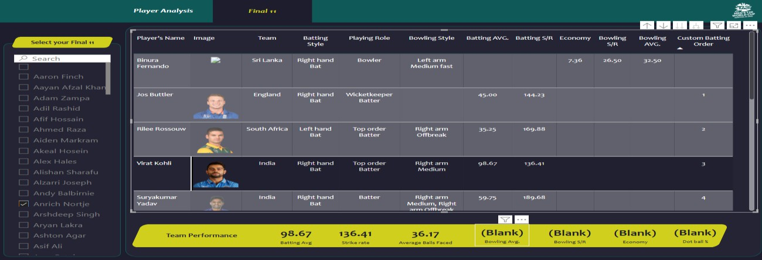

Figure A2.1 Power BI dashboard 1

In this figure A2.1 , A player analysis dashboard displays selected players’ batting and bowling statistics for a Final XI team, along with aggregated team performance metrics at the bottom.

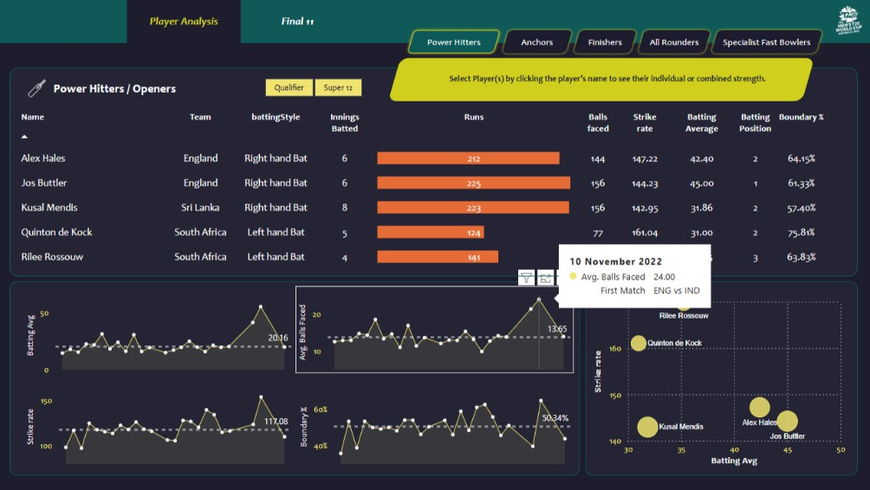

Figure A2.2 Power BI dashboard 2

In this figure A2.2, a dashboard visualizes performance metrics of power hitters/openers, comparing their runs, strike rates, and boundary percentages, with additional insights shown through interactive plots and scatter charts.

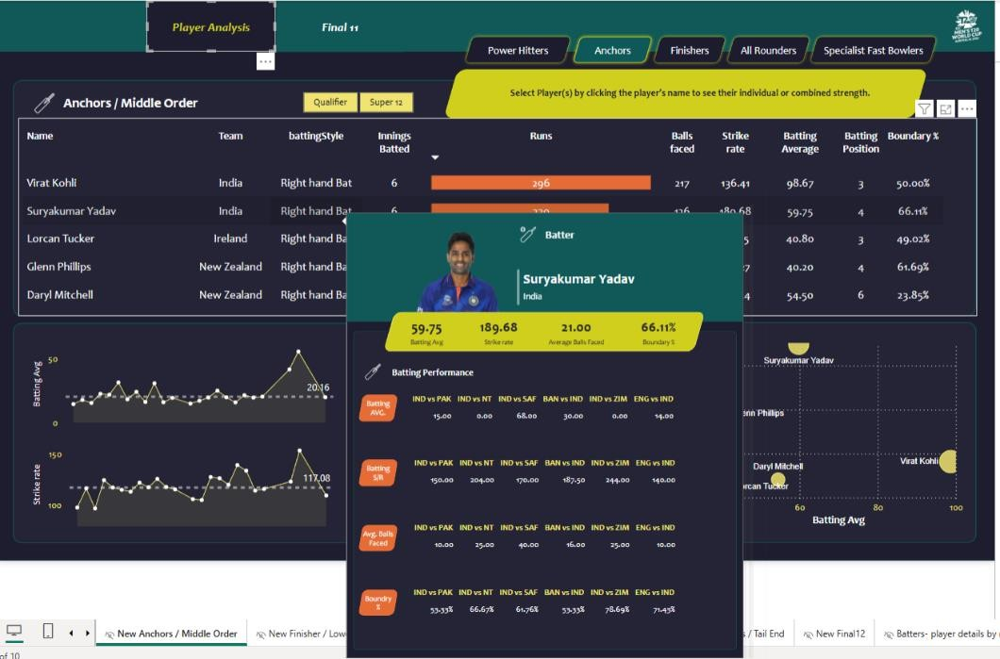

Figure A2.3 Power BI dashboard 3

In this figure A2.3, a dashboard highlights the performance of middle-order anchors with detailed metrics such as runs, strike rate, and boundary percentage, featuring an in-depth popup analysis of Suryakumar Yadav's batting stats across matches

EXCEL :

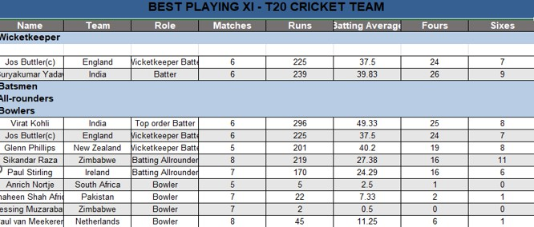

Figure A2.4 Best playing XI
In this figure A2.4, the best playing XI for a T20 cricket team is displayed, listing players by role along with their performance metrics such as matches played, runs, batting average, fours, and sixes

WEBPAGE:
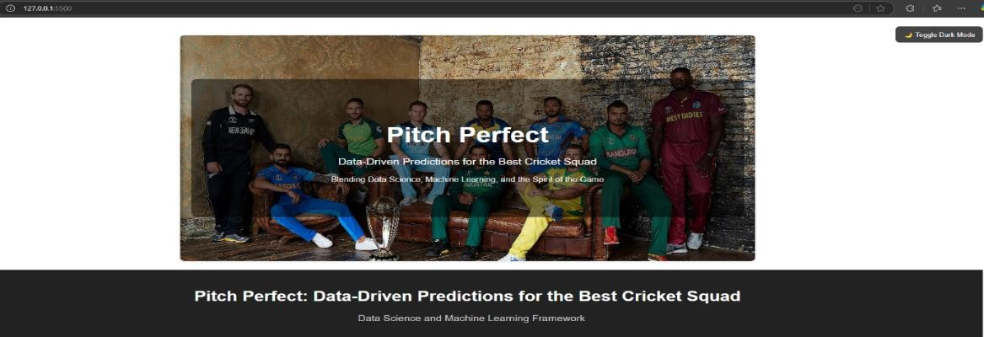
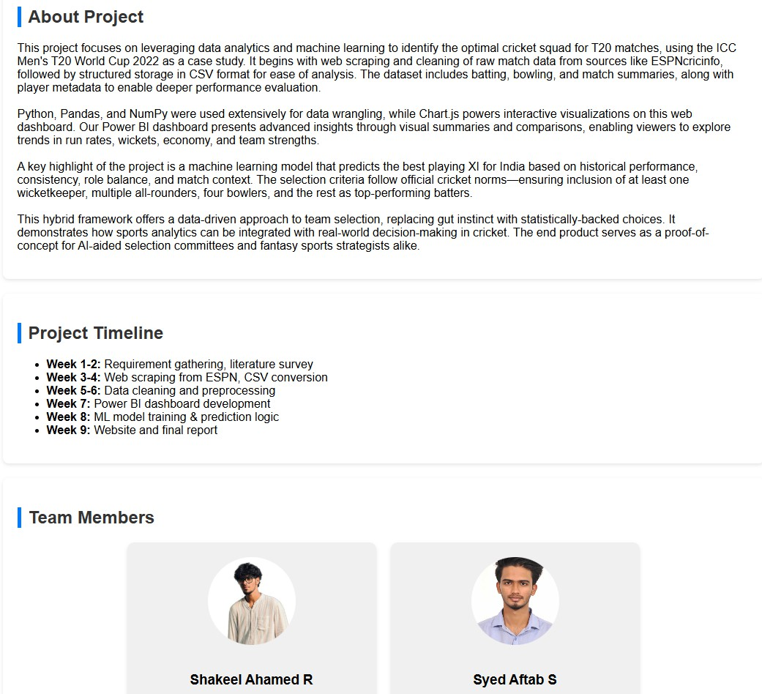
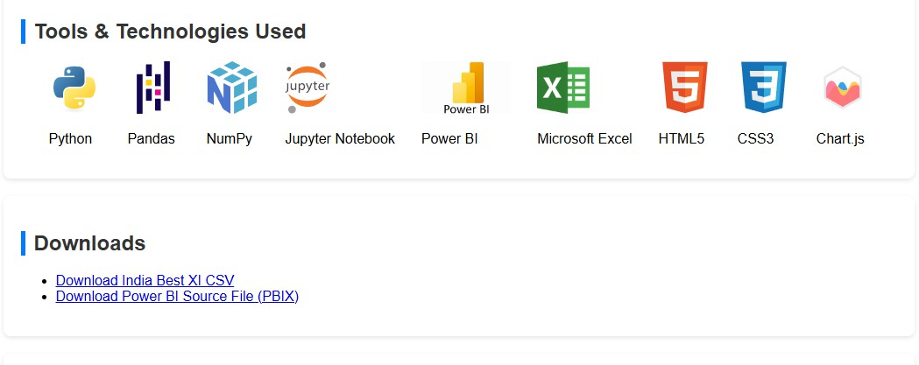

Figure A2.5 Webpage Deployment

Figure A2.5, a web application titled Pitch Perfect is showcased, highlighting a data-driven cricket squad prediction project using machine learning and analytics. It presents the project overview, timeline, team members, tools used, and provides downloadable resources for further exploration.

TECHNICAL BIOGRAPHY


Shakeel Ahamed R (210071601164), born in the year 2003 in Dindigul, Tamil Nadu, India. Completed my Intermediate in the year 2025. I am currently pursuing B. Tech in Computer Science and Engineering (CSE) at the School of Computer Science and Engineering at B.S. Abdur Rahman Crescent Institute of Science and Technology which is located at Vandalur, Chennai, India.My interests lie in areas like Web Development, Data Science, Machine Learning (ML), and Deep Learning (DL). Through this project, I was able to apply my skills in building a responsive web platform that showcases analytical insights and predictive modelling .My email for communication iamshakeelahamedr@gmail.com and my contact number +91 8525990432.



Syed Aftab S (210071601176), born in the year 2004 in Chennai, Tamil Nadu, India. Completed my Intermediate in the year 2025. I am currently pursuing B. Tech in Computer Science and Engineering (CSE) at the School of Computer Science and Engineering at B.S. Abdur Rahman Crescent Institute of Science and Technology which is located at Vandalur, Chennai, India. My interests lie in areas like Software Development, Data Science, Machine Learning (ML), and Deep Learning (DL). This project allowed me to explore full-cycle development from data scraping and processing to implementing ML algorithms .My email for communication afuus03@gmail.com and my contact number +918637604703

SHAKEL AHMED

main doc.docx
My Files My Files University

Document Details

Submission ID trn:oid:::17268:91693041

48 Pages

12,437 Words

72,308 Characters
Submission Date
Apr 17, 2025, 6:50 PM GMT+5:30

Download Date
Apr 17, 2025, 6:53 PM GMT+5:30

File Name main doc.docx
File Size
1.1 MB

3% Overall Similarity

The combined total of all matches, including overlapping sources, for each database.

Match Groups

39 Not Cited or Quoted 3%
Matches with neither in-text citation nor quotation marks

5 Missing Quotations 1%

Matches that are still very similar to source material


0 Missing Citation 0%

Matches that have quotation marks, but no in-text citation

0 Cited and Quoted 0%

Matches with in-text citation present, but no quotation marks

Top Sources

2% | Internet sources
1% | Publications
2% | Submitted works (Student Papers)

Integrity Flags
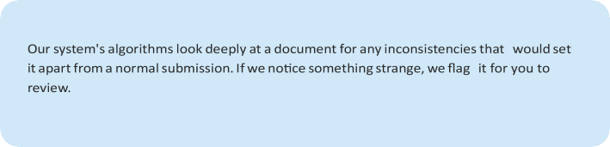
0 Integrity Flags for Review
No


Page 2 of 72 - Integrity Overview Submission ID trn:oid:::17268:91693041

